IQAC 2021-2022

Key Indicator – 4.2:
4.2.1.

- NETLIB
- Fully Automated
- Vidyut
- 1999-2002

Focus on / Query for:

- Vidyut version software ability- Accessioning, Cataloguing, Searching, Bar-coding, Spine Label Printing, Resource Location indicator, Online Public Access Catalogue, Circulation, Administration, Periodicals entry / indexing etc.

- Combined with above
- Yes. http://gargicollege.saraswatilib.com/ . Feedback Form.
- N.A.

Following aspects:

- N.A.
- N.A.
- Via N-List & DULS
- 09 (Nine)
- N.A.
- 100 MBPS
- N.A.
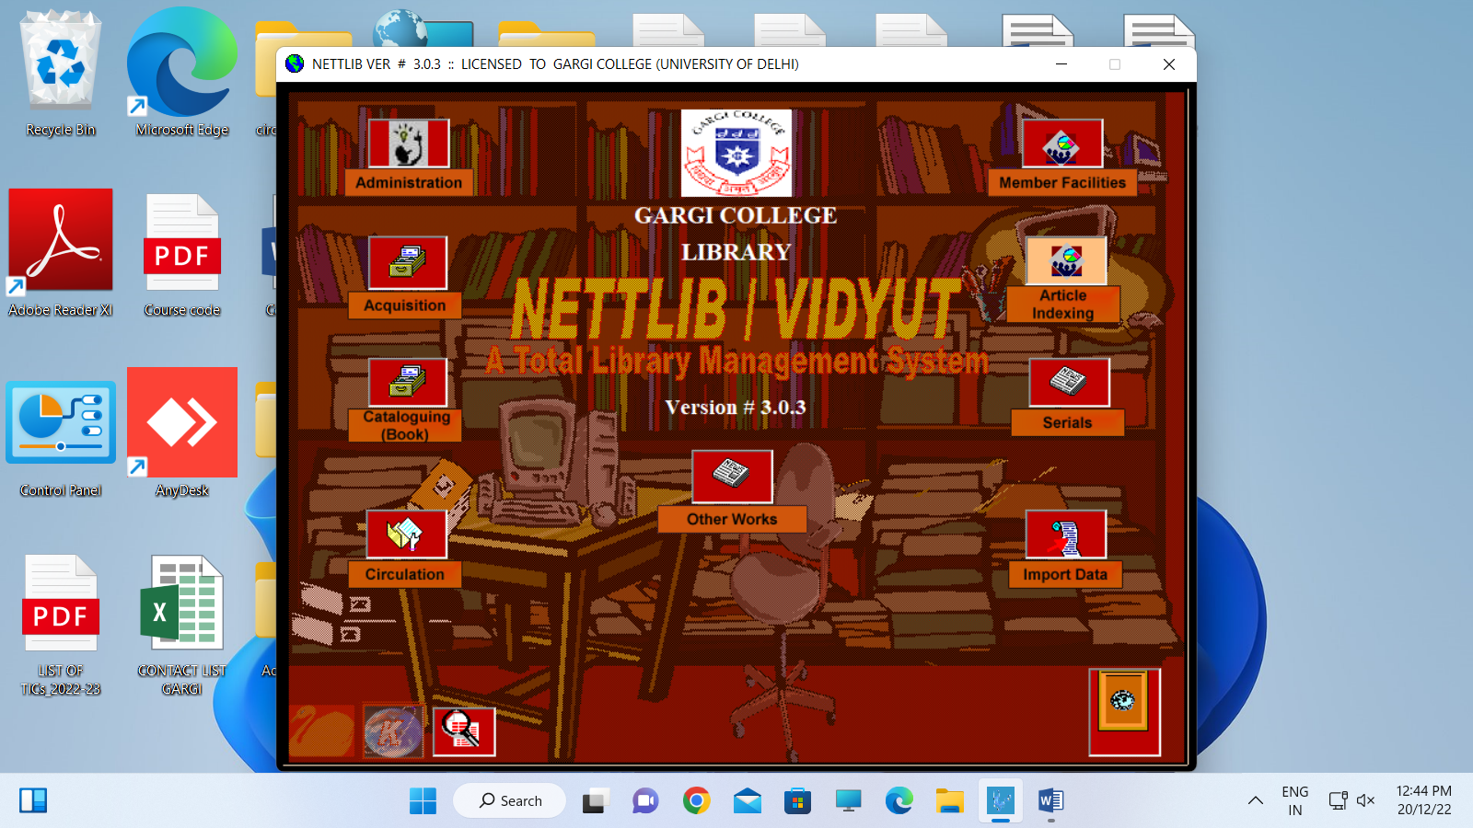
- http://gargicollege.saraswatilib.com/

Supporting Documents:

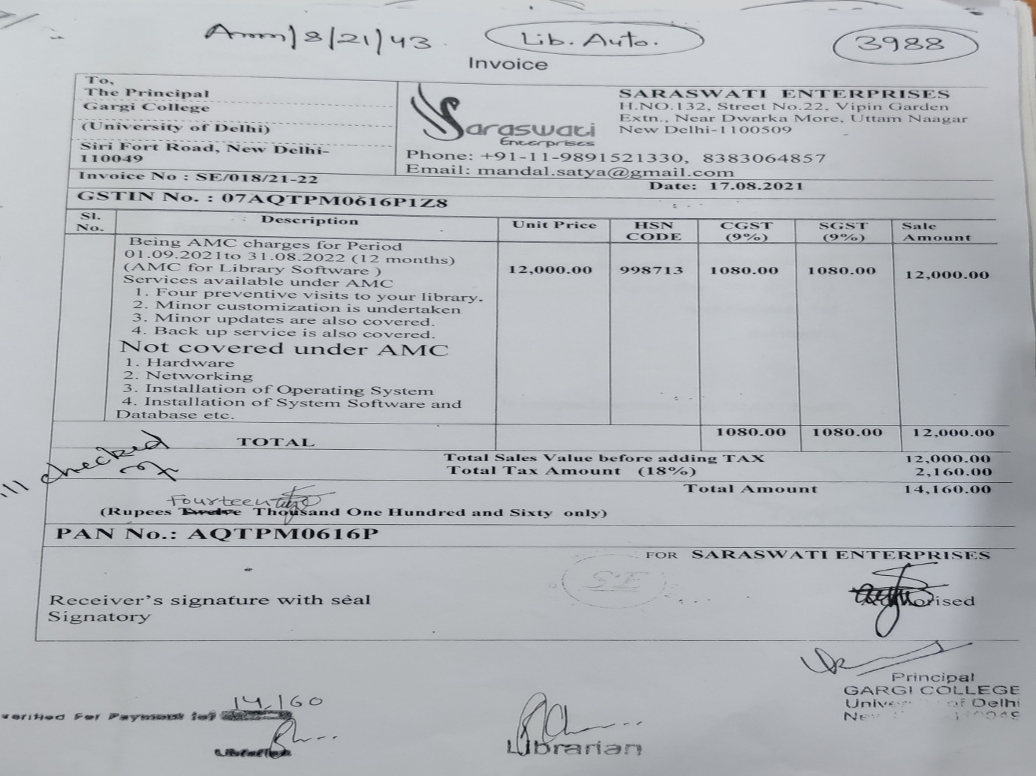

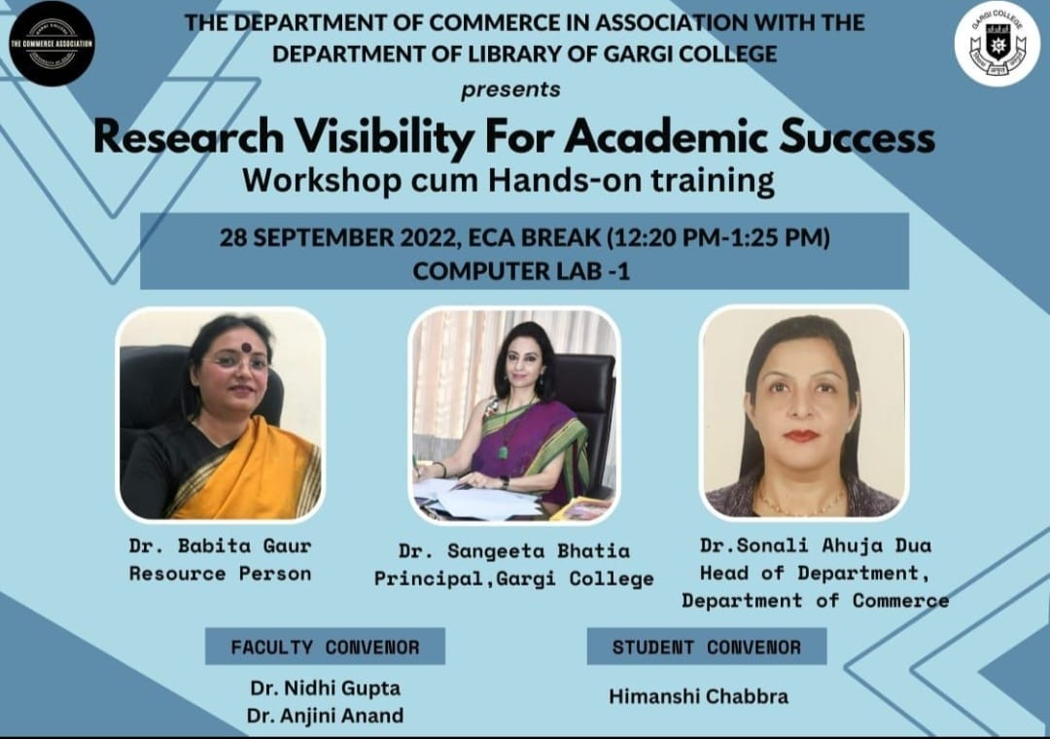

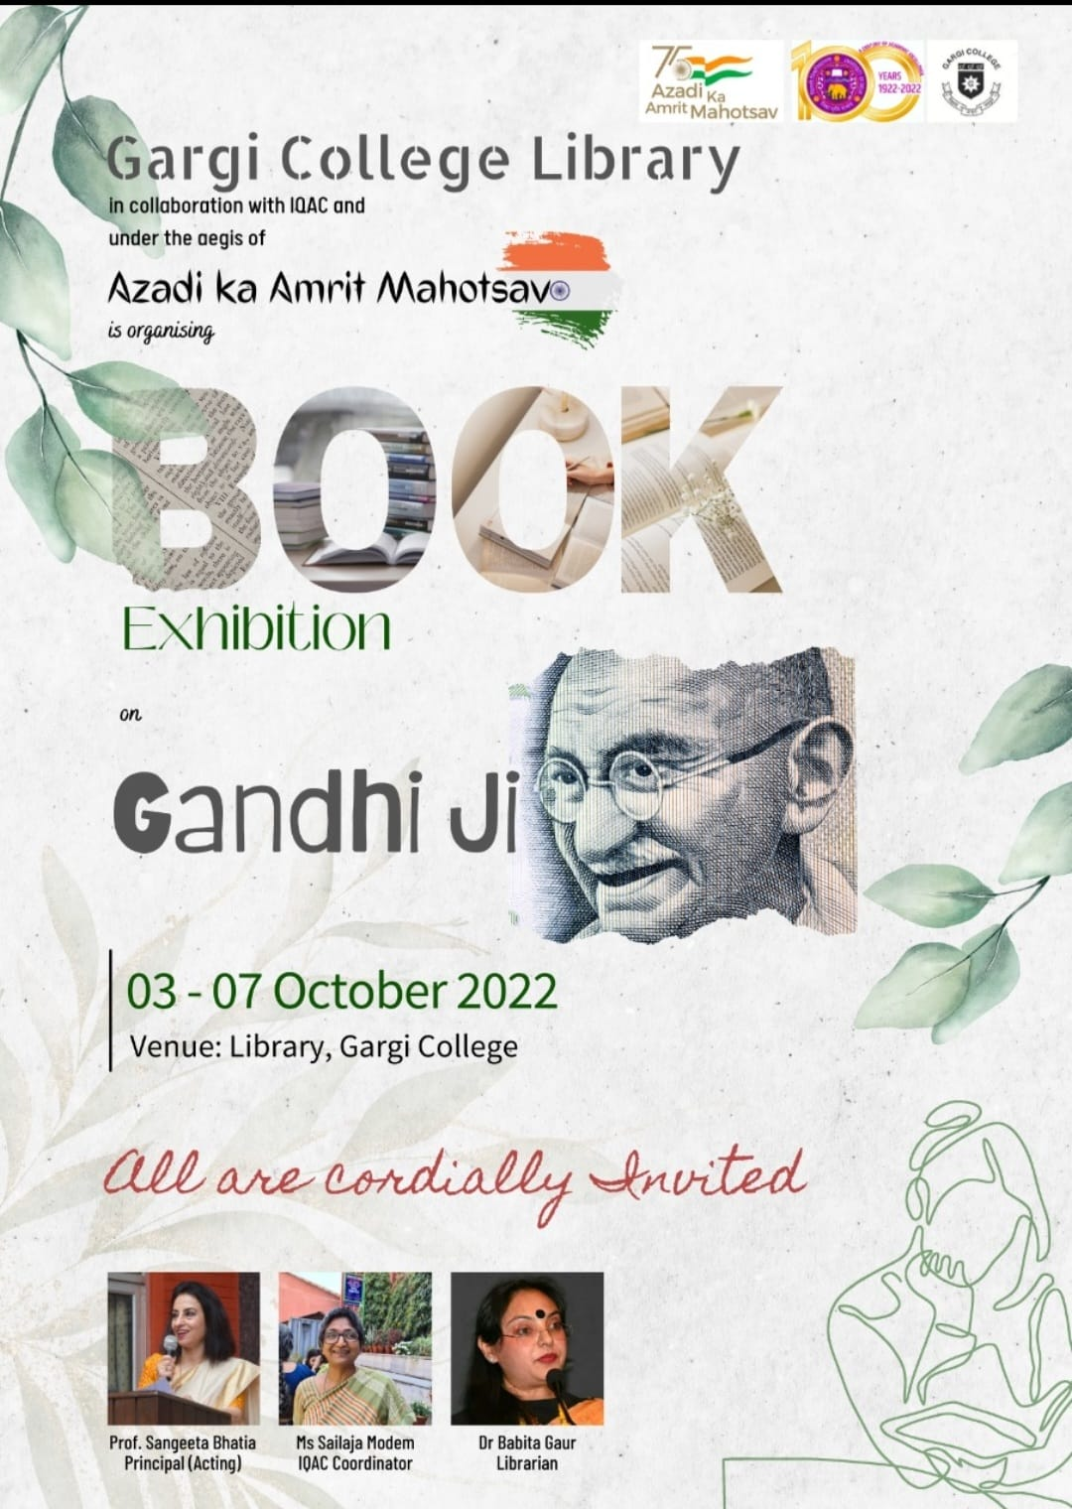

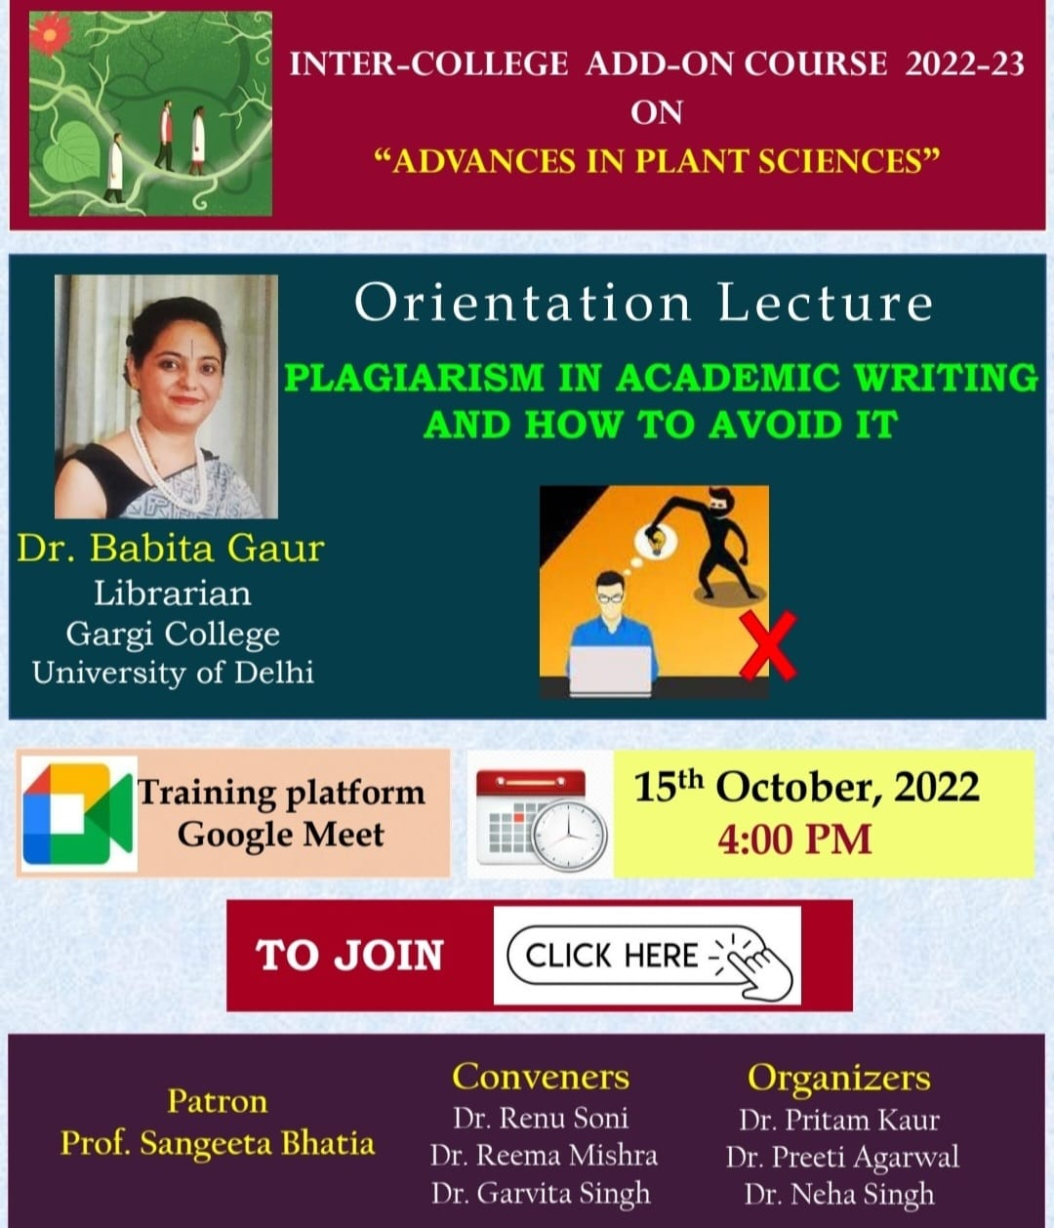

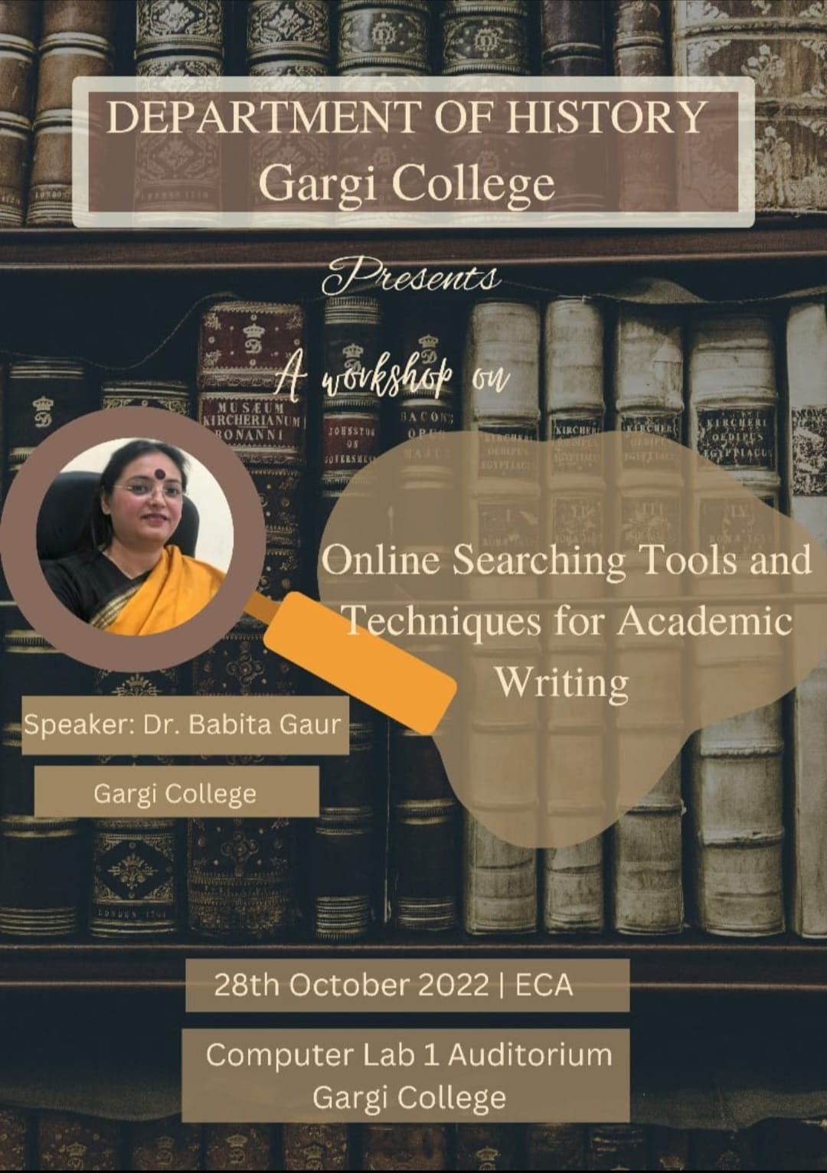

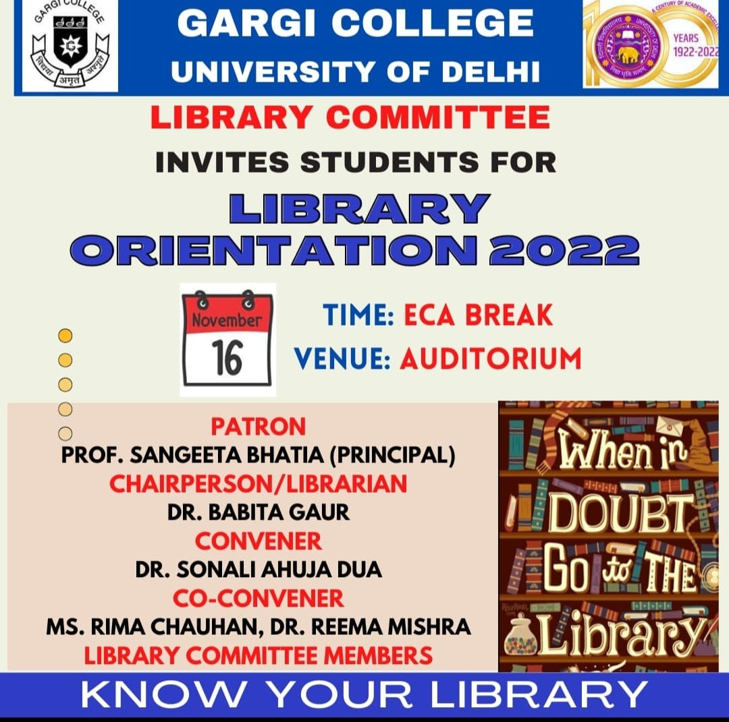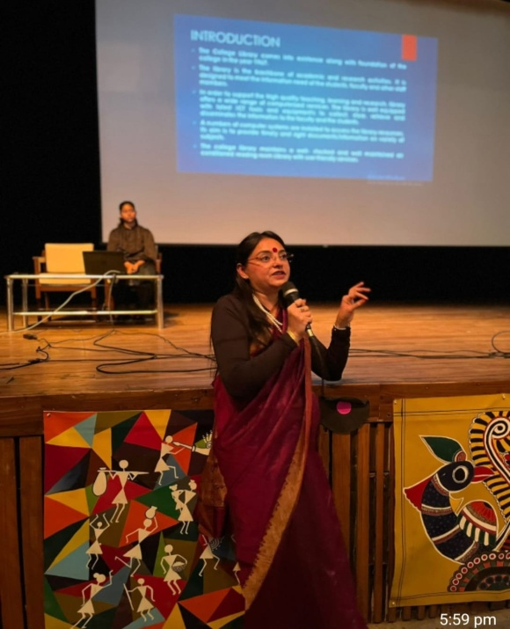

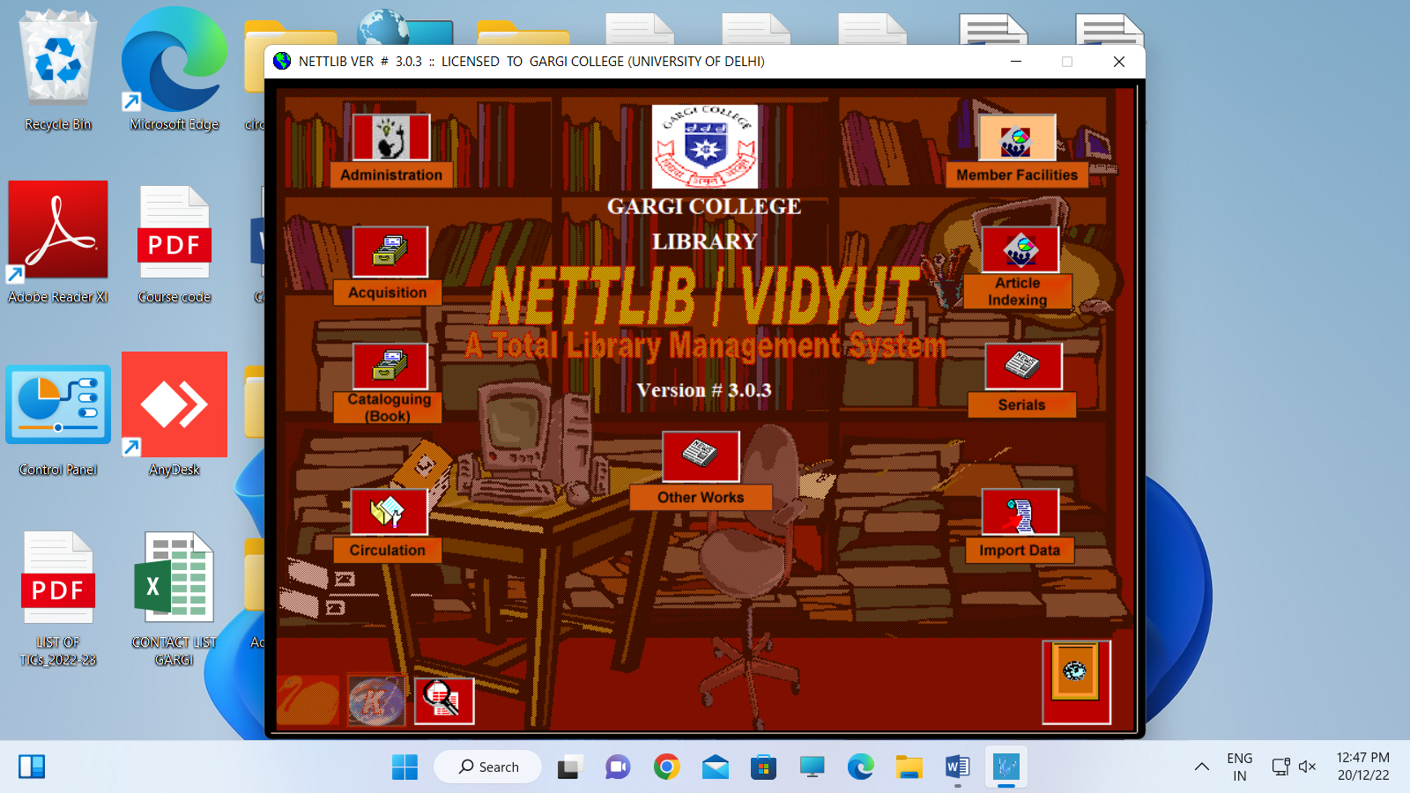

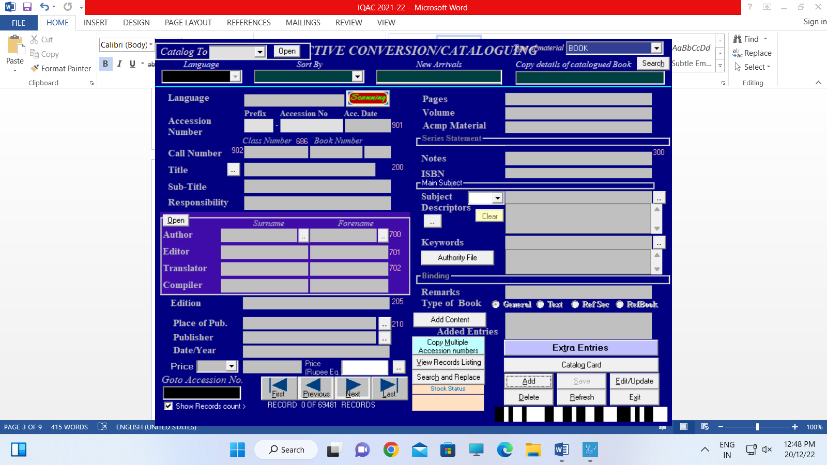

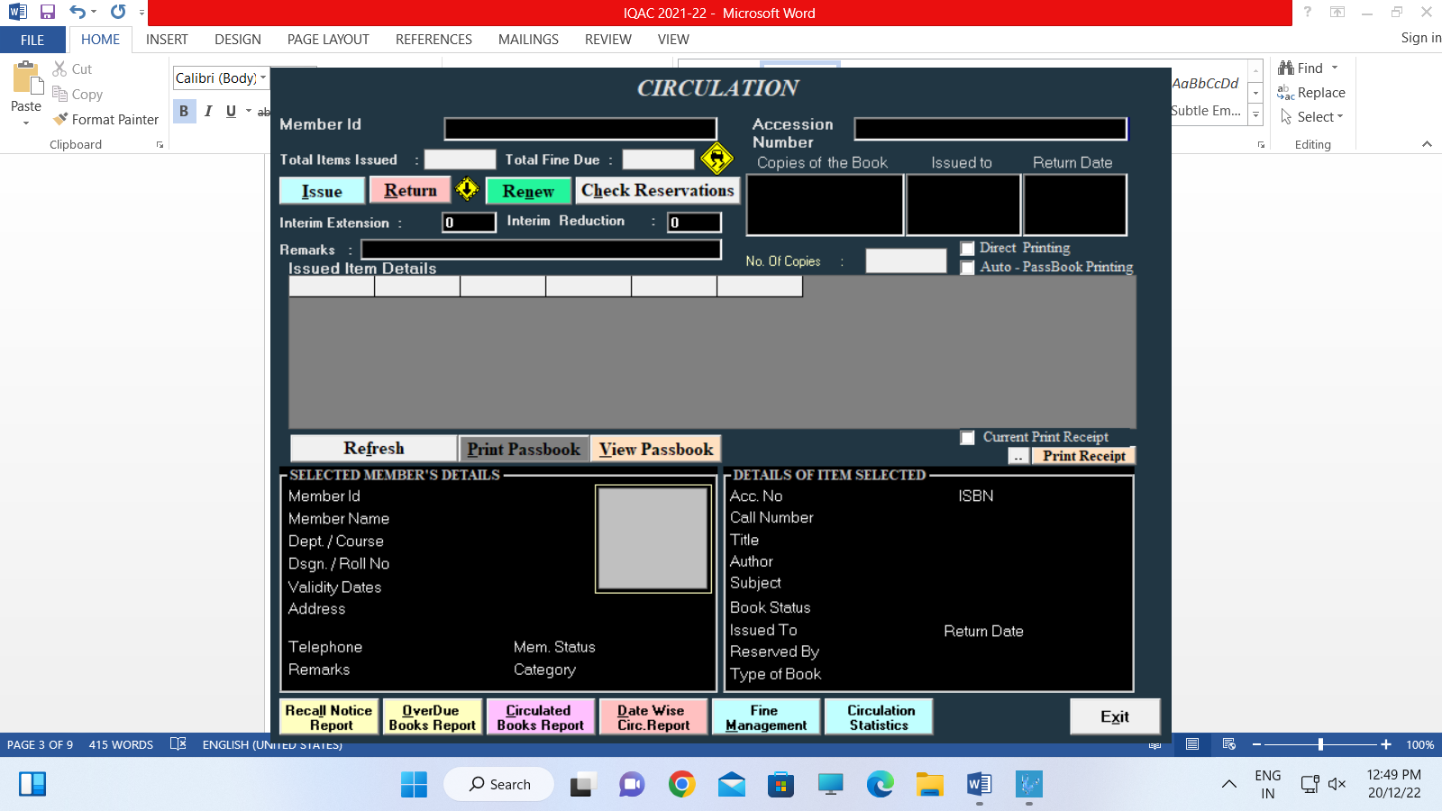

4.2.2:

- Through N-List & DULS
- N.A.
- N.A.
- Through N-List & DULS
- -do-
- -do-
Data template:

Library resources | If yes, details of  membership / subscription | Expenditure on subscription to –journals, e-Books | Expenditure on subscription to other e-resources | Total Library Expenditure | Link to the relevant document
Books |  |  |  | 504577 | https://nlist.inflibnet.ac.in/  https://crl.du.ac.in/
Journals |  |  |  | 131668
e-Journals | From INFLIBNET & DULS Membership  As per available records, UGC INFLIBNET & DULS
e-Books
e-ShodhSindhu
Shodhganga
Databases
Remote access to resources

Focus on / Query for:

- N.A.

Supporting Documents:

- Through N-List & DULS

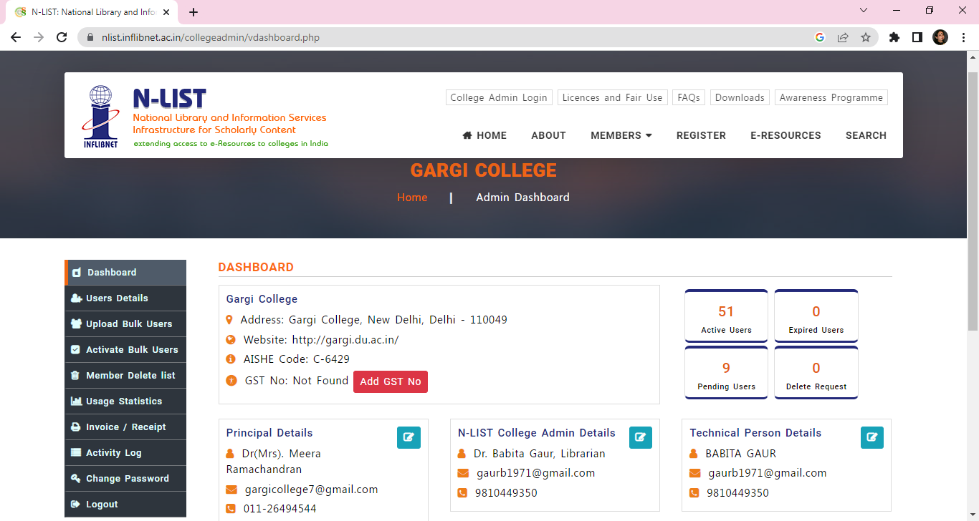

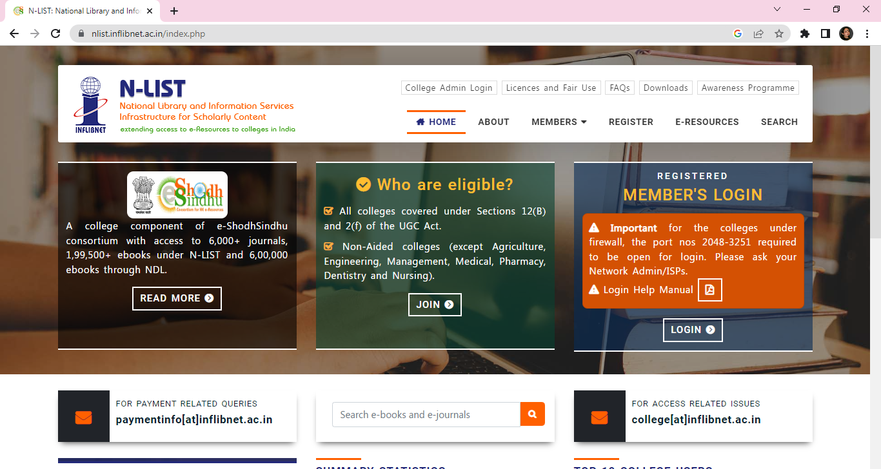

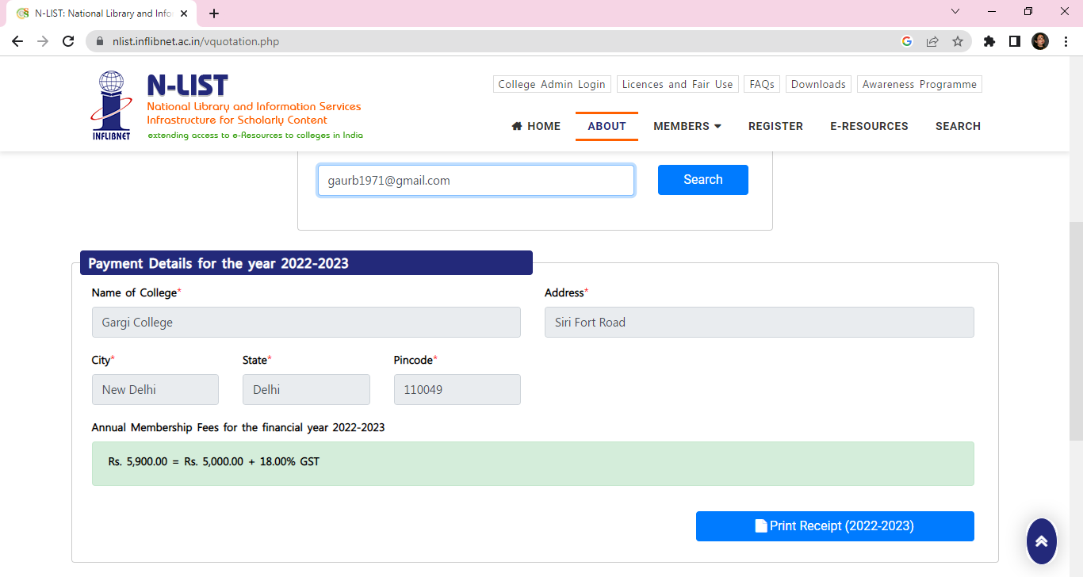

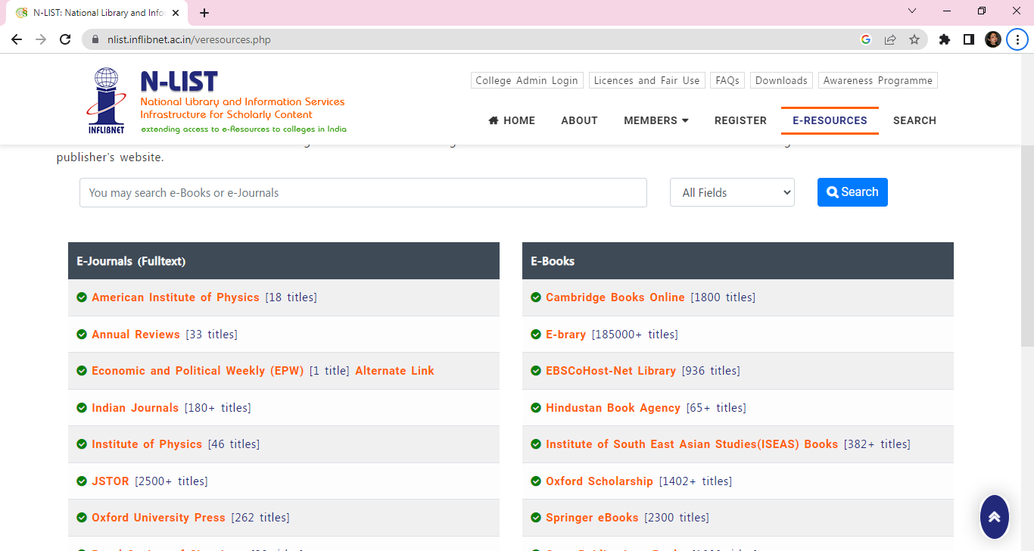

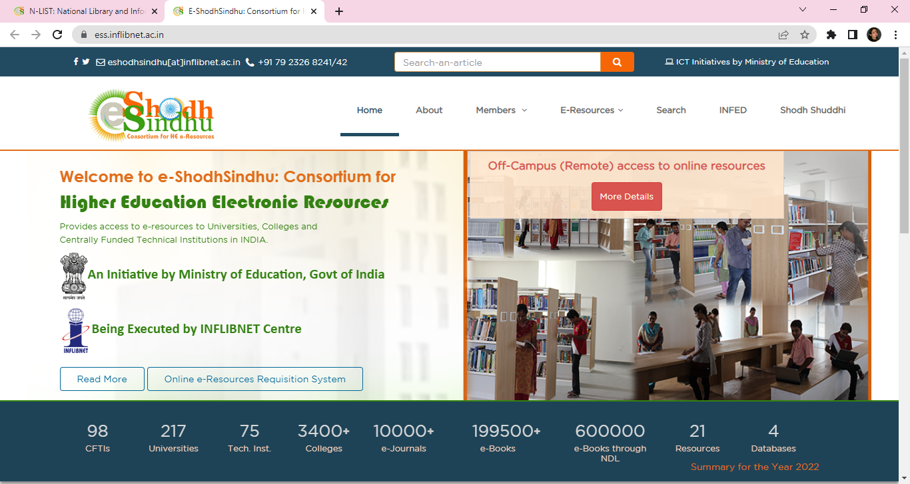

4.2.3:
4.2.3.1:

Physical Books Expenditure= Rs. 504577. (FY 2021-22)

4.2.2:

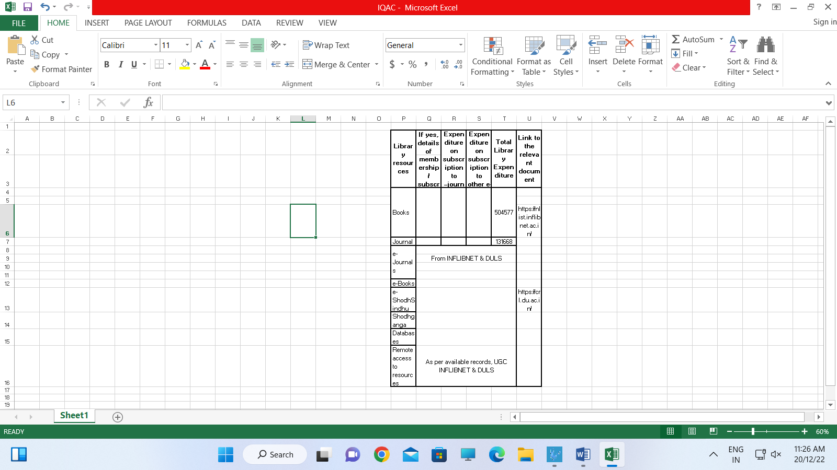

Supporting Documents:

S.No. | Bill Date | B.R. No. | Amount | Grant
1 | 12/04/21 | Amn/4/21/39 | 1416 | Lib.Auto.
2 | 06/07/21 | Amn/7/21/40 | 4700 | Lib.Auto.
3 | 03/03/21 | Amn/8/21/41 | 33866 | Lib.Auto.
4 | 12/08/21 | Amn/8/21/42 | 2200 | Lib.Auto.
5 | 17/08/21 | Amn/8/21/43 | 14160 | Lib.Auto.
6 | 09/07/21 | Amn/7/21/44 | 64900 | Lib.Auto.
7 | 19/10/21 | Amn/10/21/45 | 650 | Lib.Auto.
8 | 10/01/22 | Amn/1/22/46 | 8600 | Lib.Auto.
9 | 07/03/22 | Amn/3/22/47 | 12246 | Lib.Auto.
10 | 13/08/21 | Dr. Neeraj K Singh | 2000 | Webinar
11 | 13/08/21 | Dr. Sanjay Kataria | 2000 | Webinar
12 | 25/01/22 | Inflibnet / N-List/2022/1007 | 5900 | Lib.Auto.
 |  |  | Total | 152638
S.No. | SUBJECT | RS | TB | GEN | TOTAL BOOKS | AMOUNT
1 | Physics | - | 05 | 27 | 32 | 16234
2 | Chemistry | 01 | 06 | 14 | 21 | 28042
3 | Mathematics | 03 | - | 19 | 22 | 34425
4 | Microbiology | 02 | - | 02 | 04 | 26845
5 | Zoology | 01 | 11 | 12 | 24 | 37958
6 | Botany | 03 | 06 | 10 | 19 | 34471
7 | History | 09 | - | 22 | 31 | 53845
8 | English | 03 | - | 38 | 41 | 39873
9 | Pol. Science | 07 | - | 32 | 39 | 51257
10 | Psychology | 05 | - | 07 | 12 | 28767
11 | Hindi | - | - | 74 | 74 | 24142
12 | Commerce | - | 10 | 44 | 54 | 26170
13 | Economics | 01 | - | - | 01 | 13201
14 | Philosophy | 01 | - | 27 | 28 | 16694
15 | Education | 07 | - | 02 | 09 | 27506
16 | Generalia | 02 | - | 04 | 06 | 10848
17 | Sport | - | - | 20 | 20 | 9520
18 | Sanskrit | 05 | - | 51 | 56 | 24779
 | TOTAL | 50 | 38 | 405 | 493 | 504577

4.2.4:
4.2.4.1.

Teachers = 03 approx. & Students = 250 approx.

Data Requirements:

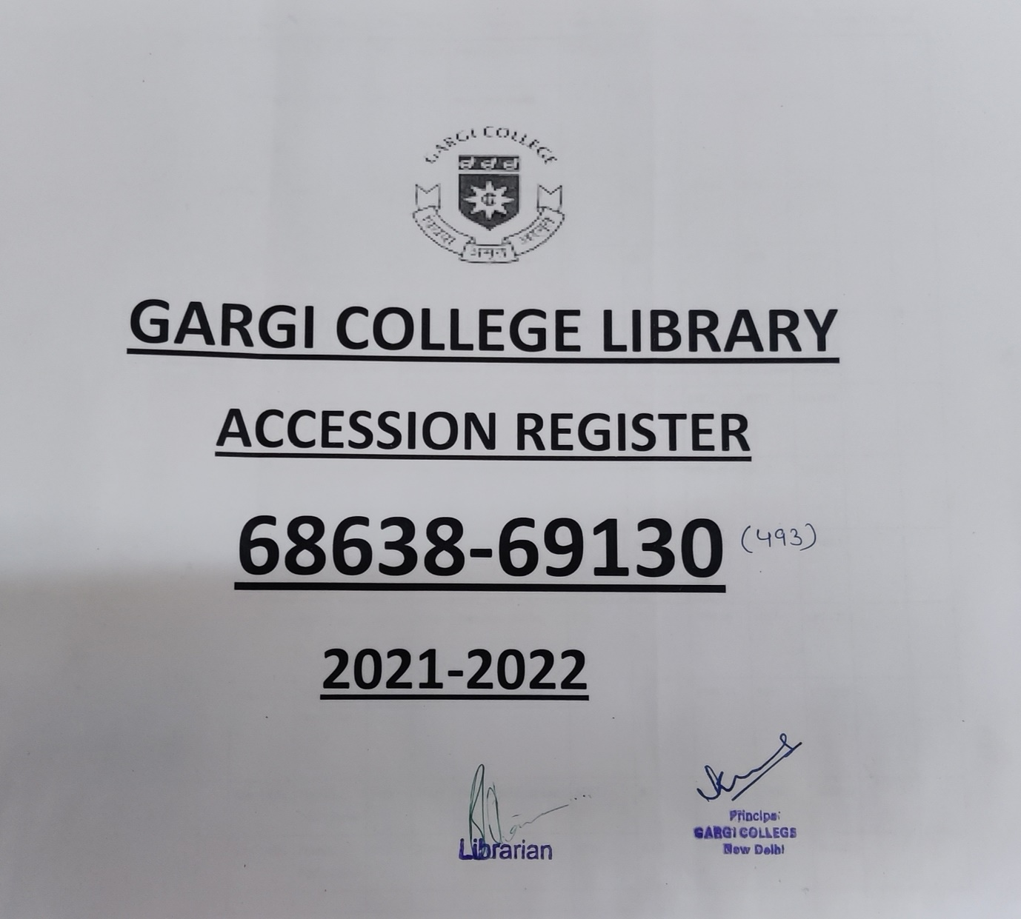

- Scanner at checking point as well as Physical Register
- N.A.
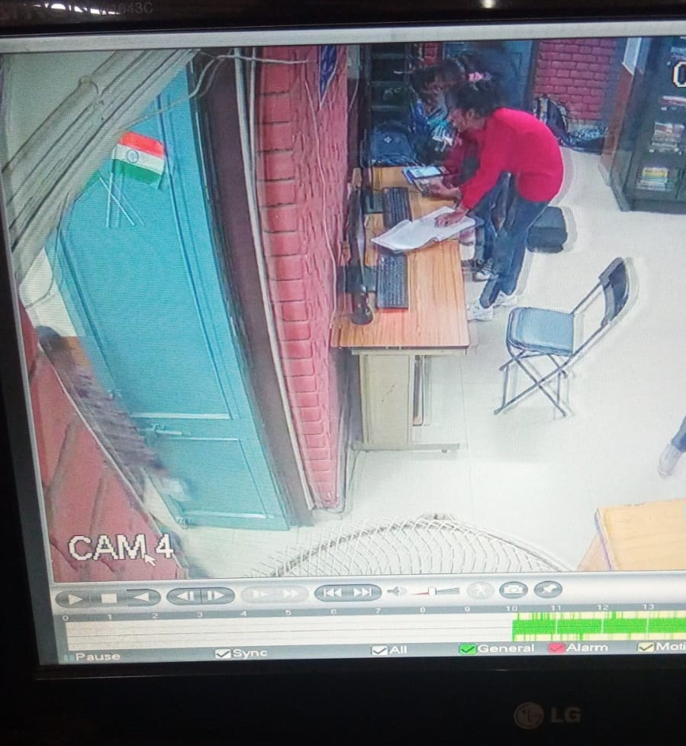

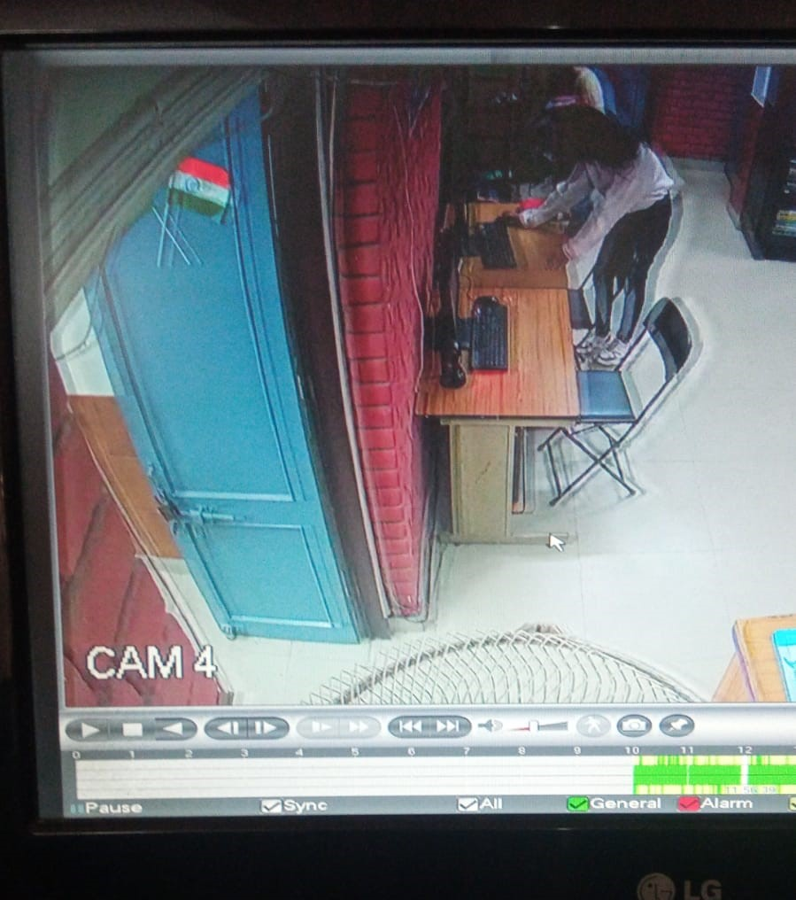
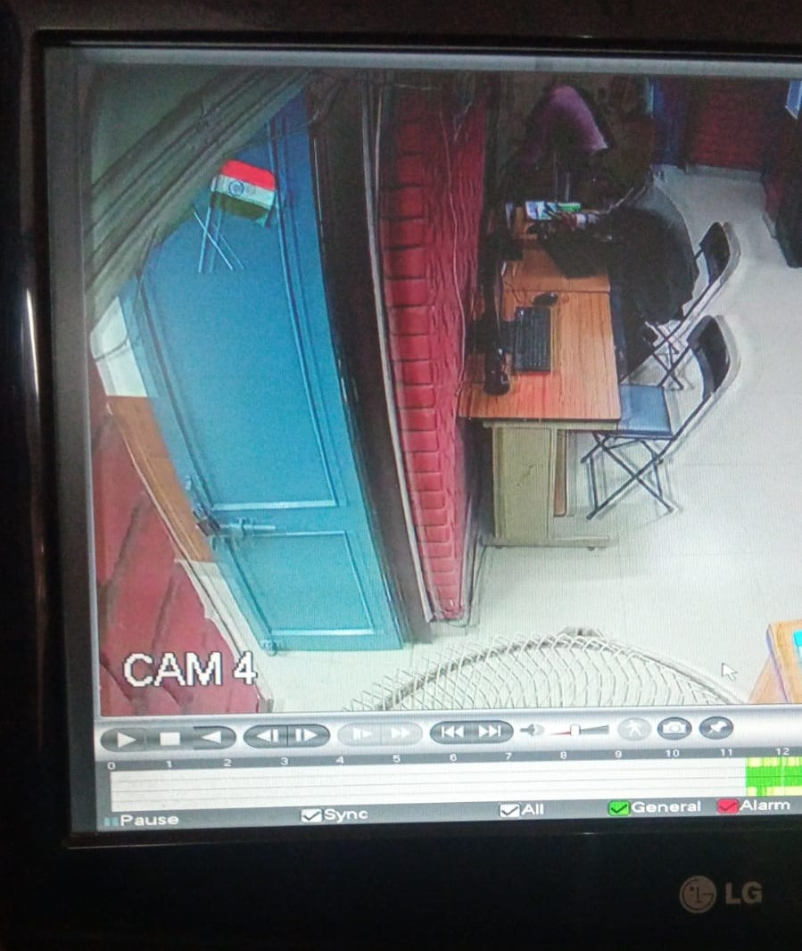

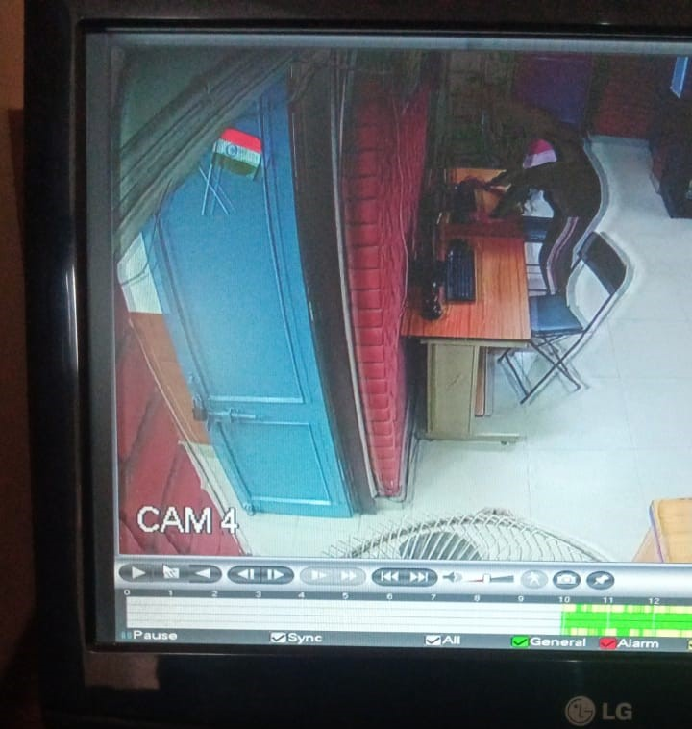

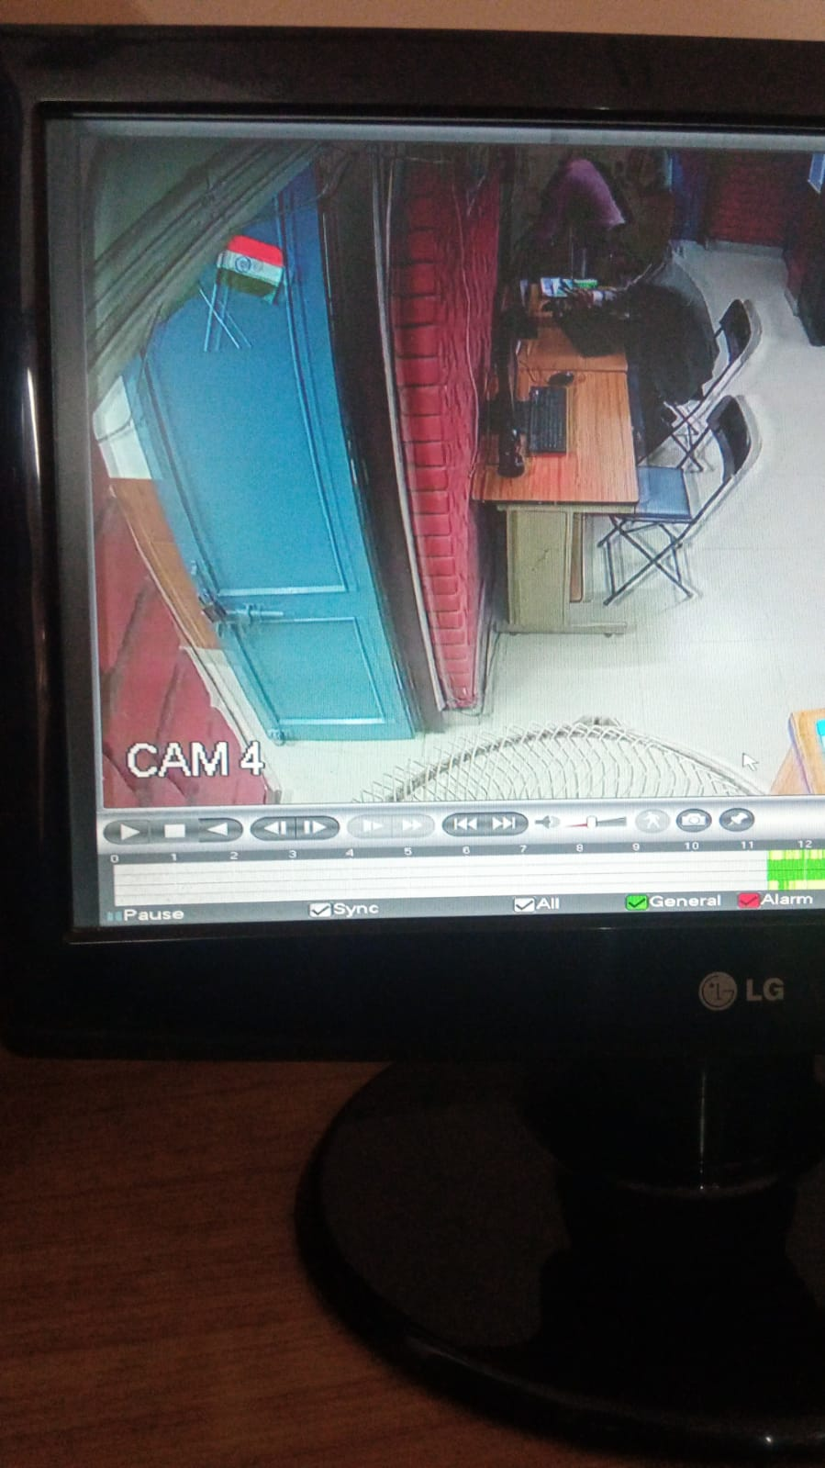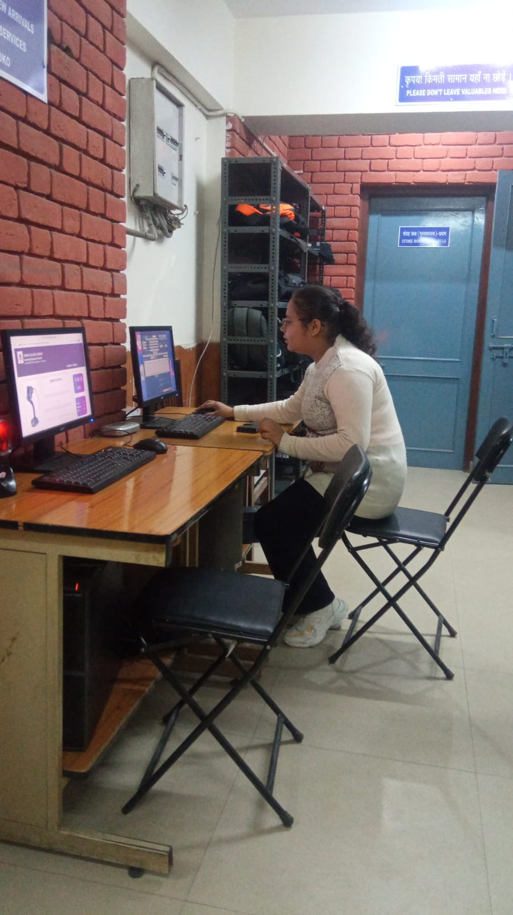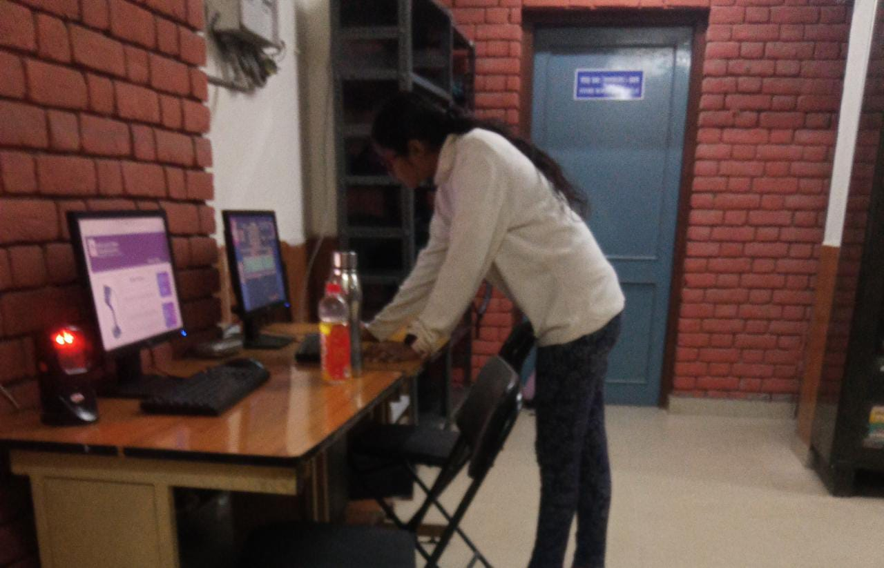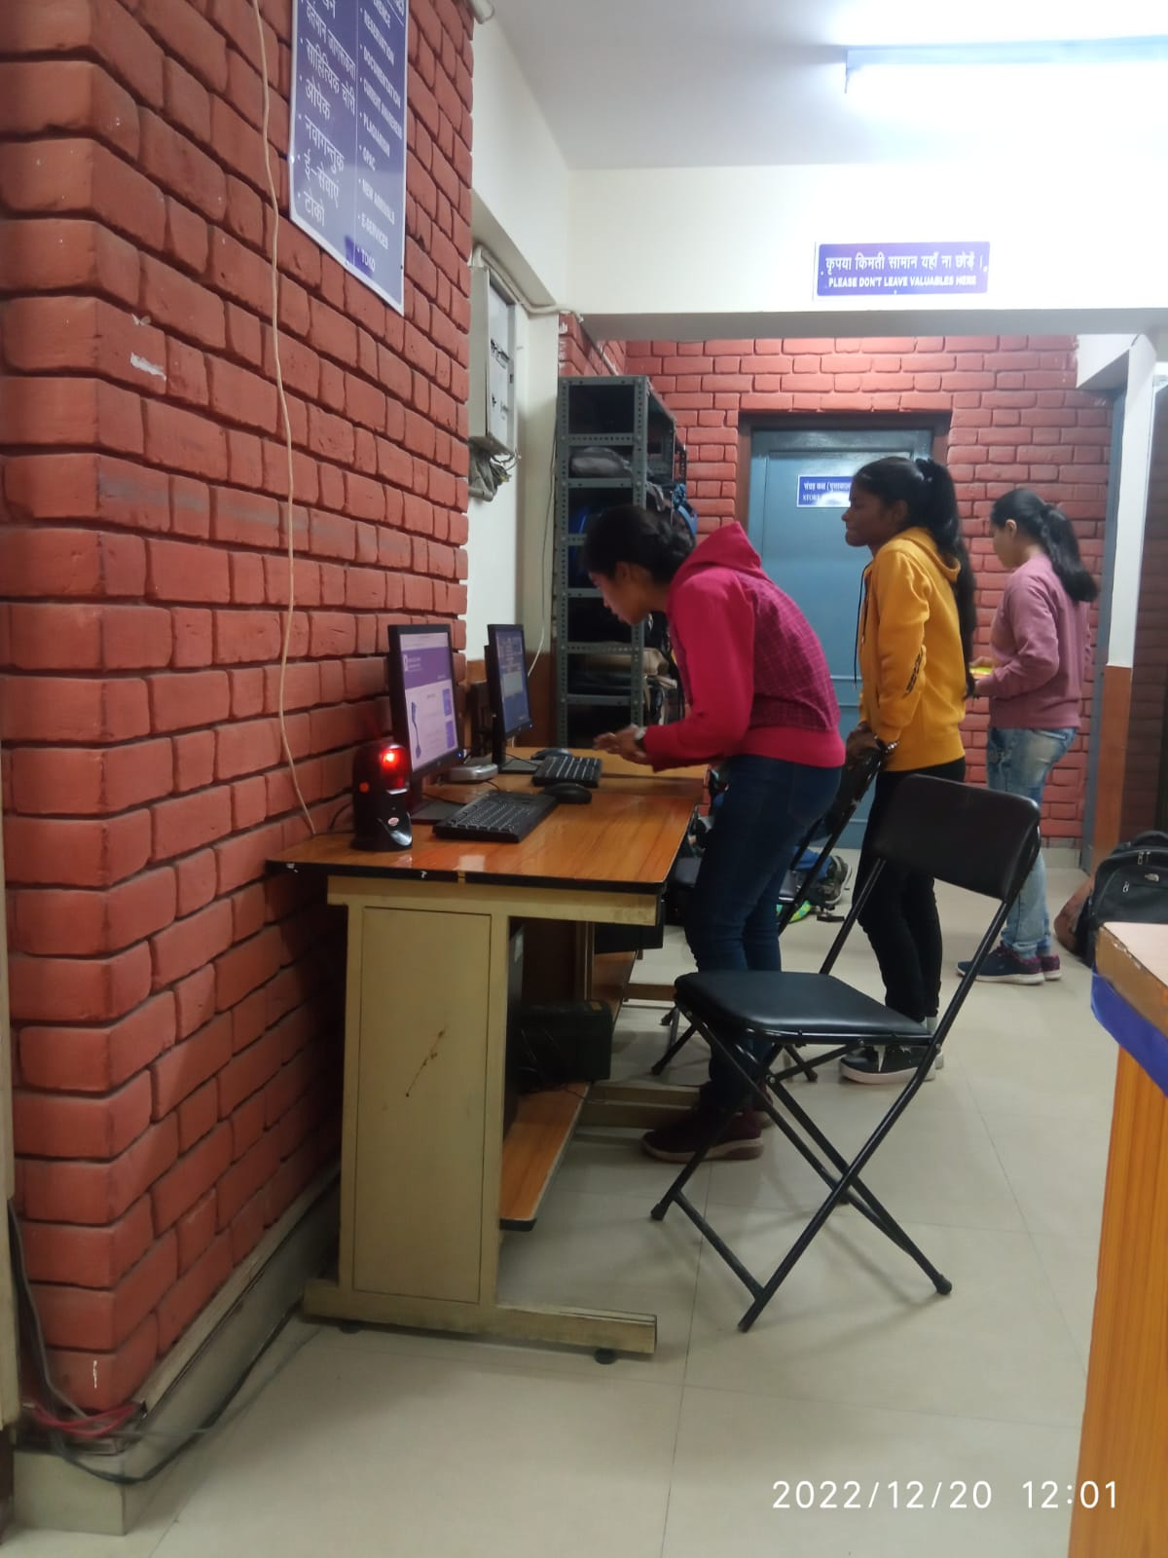
- 260 approx.
Supporting Documents:

260 per day approx.

Through e-access
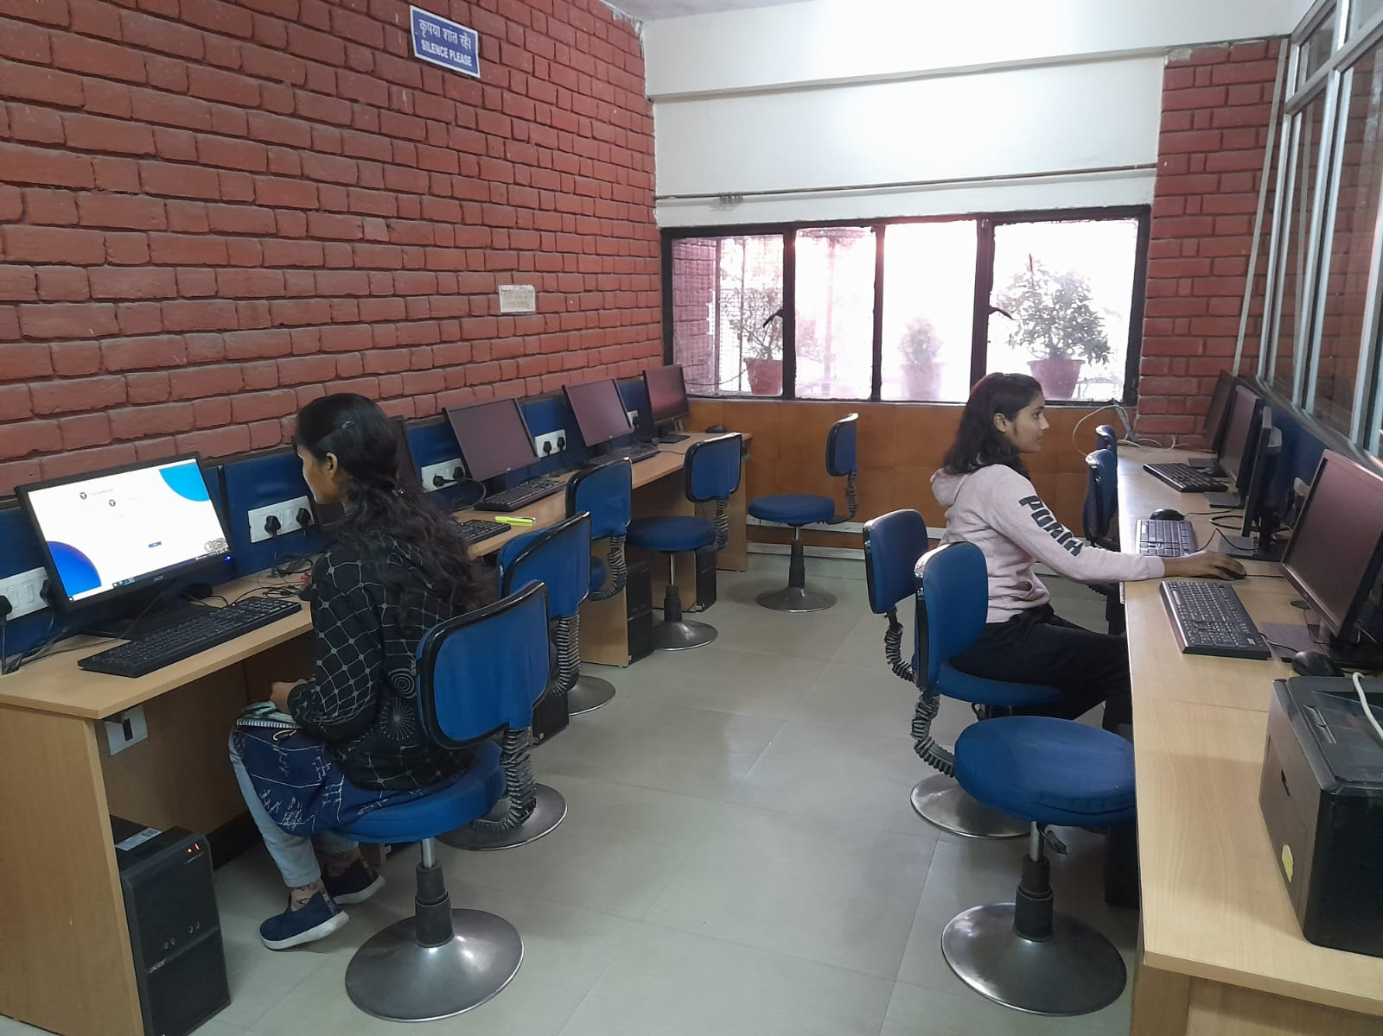
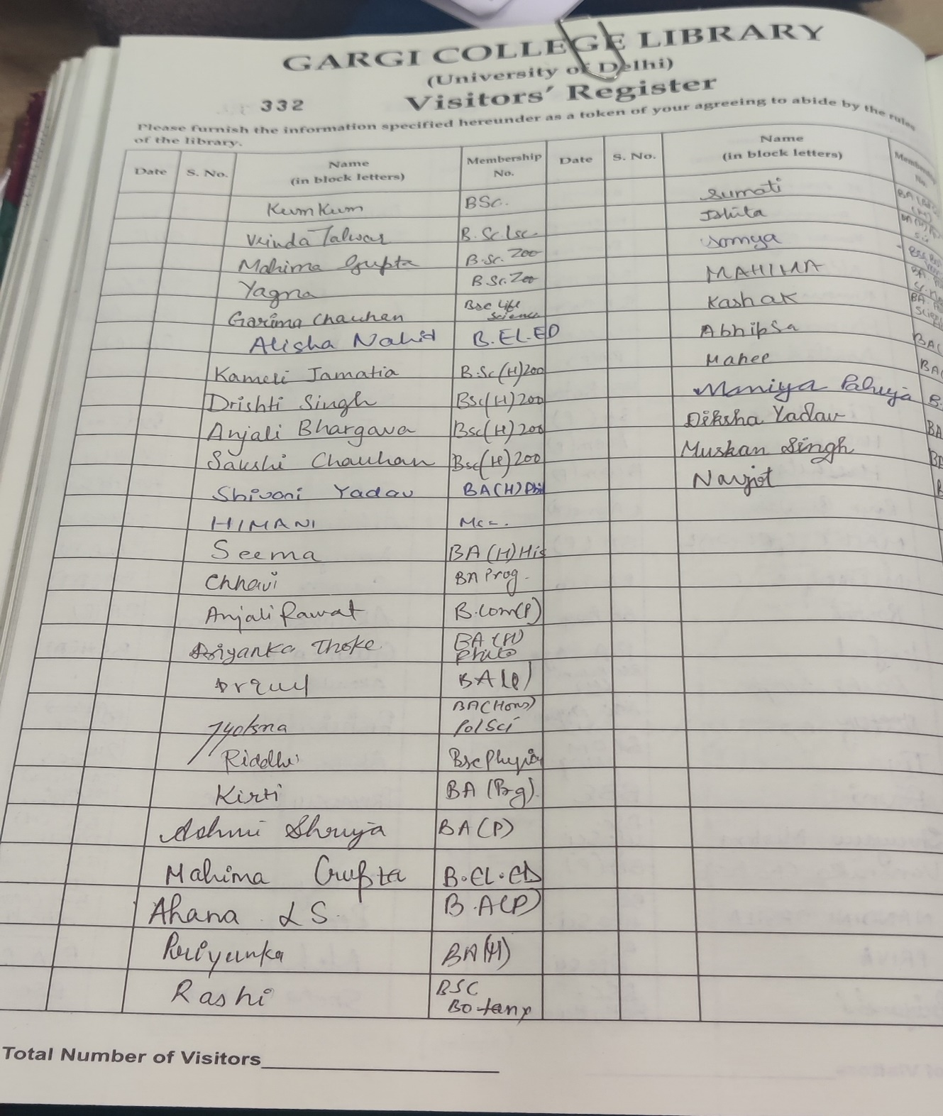

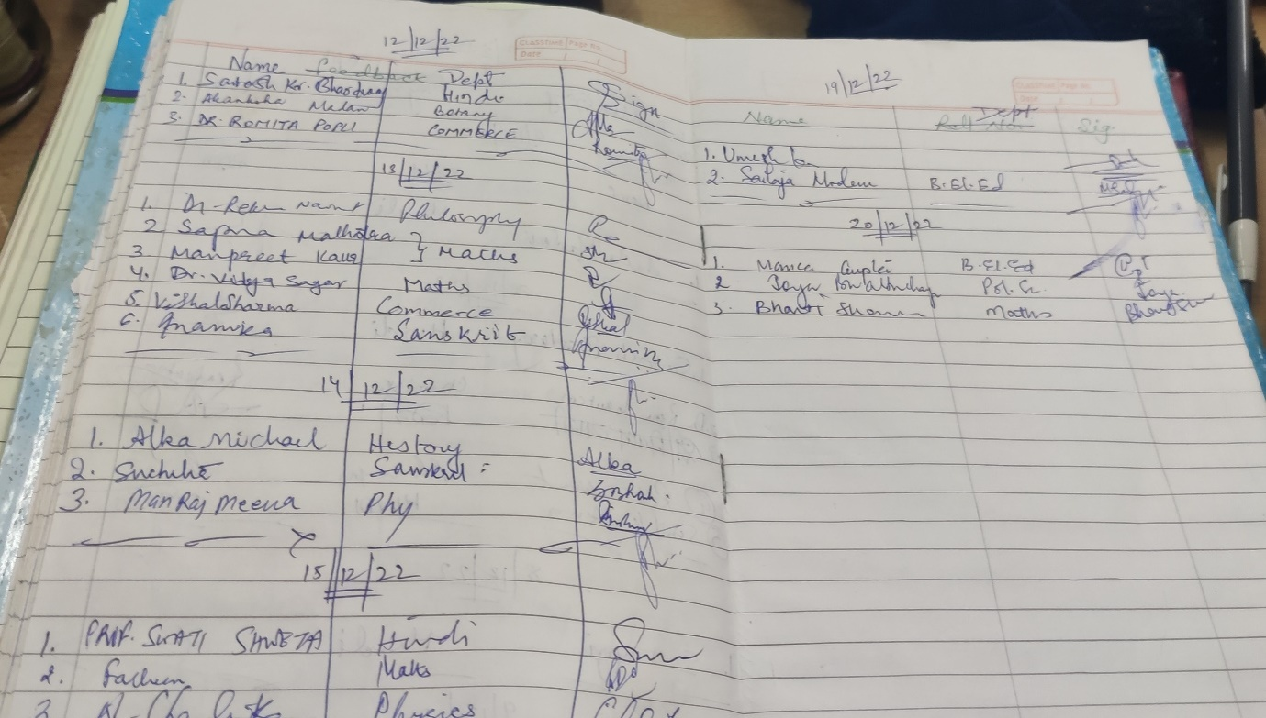

253 per day approx.

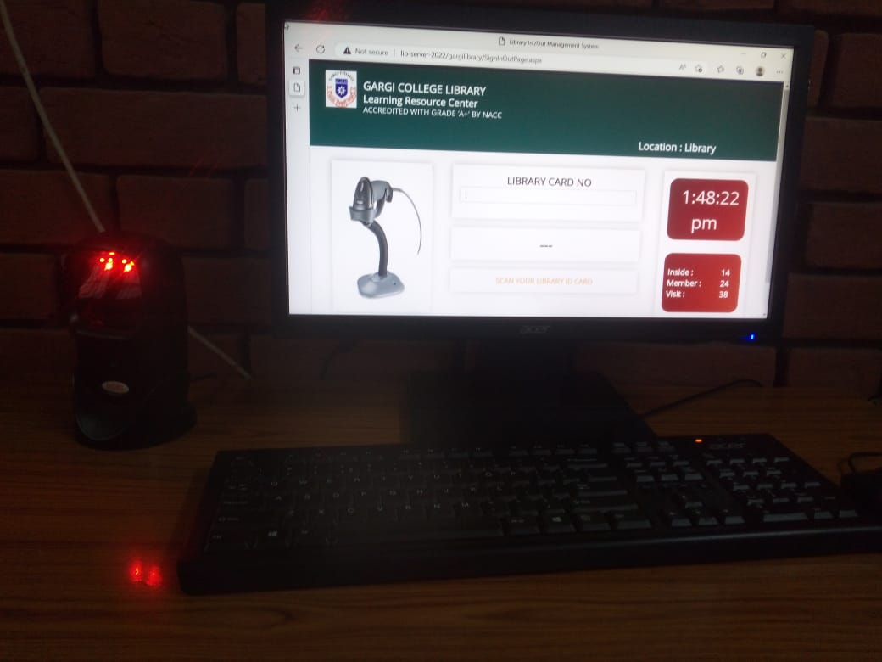

4.4.2 Library Committee minutes
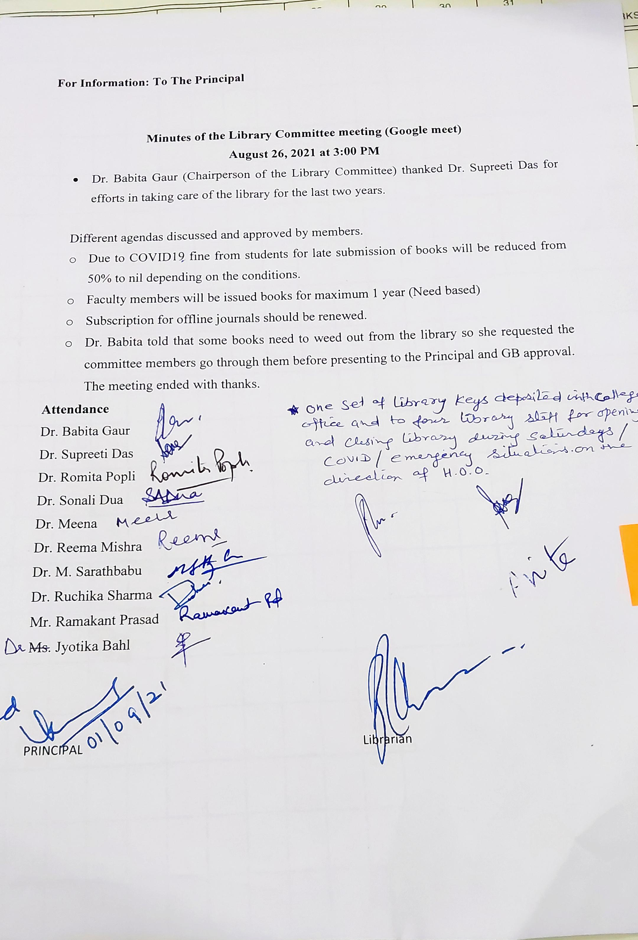

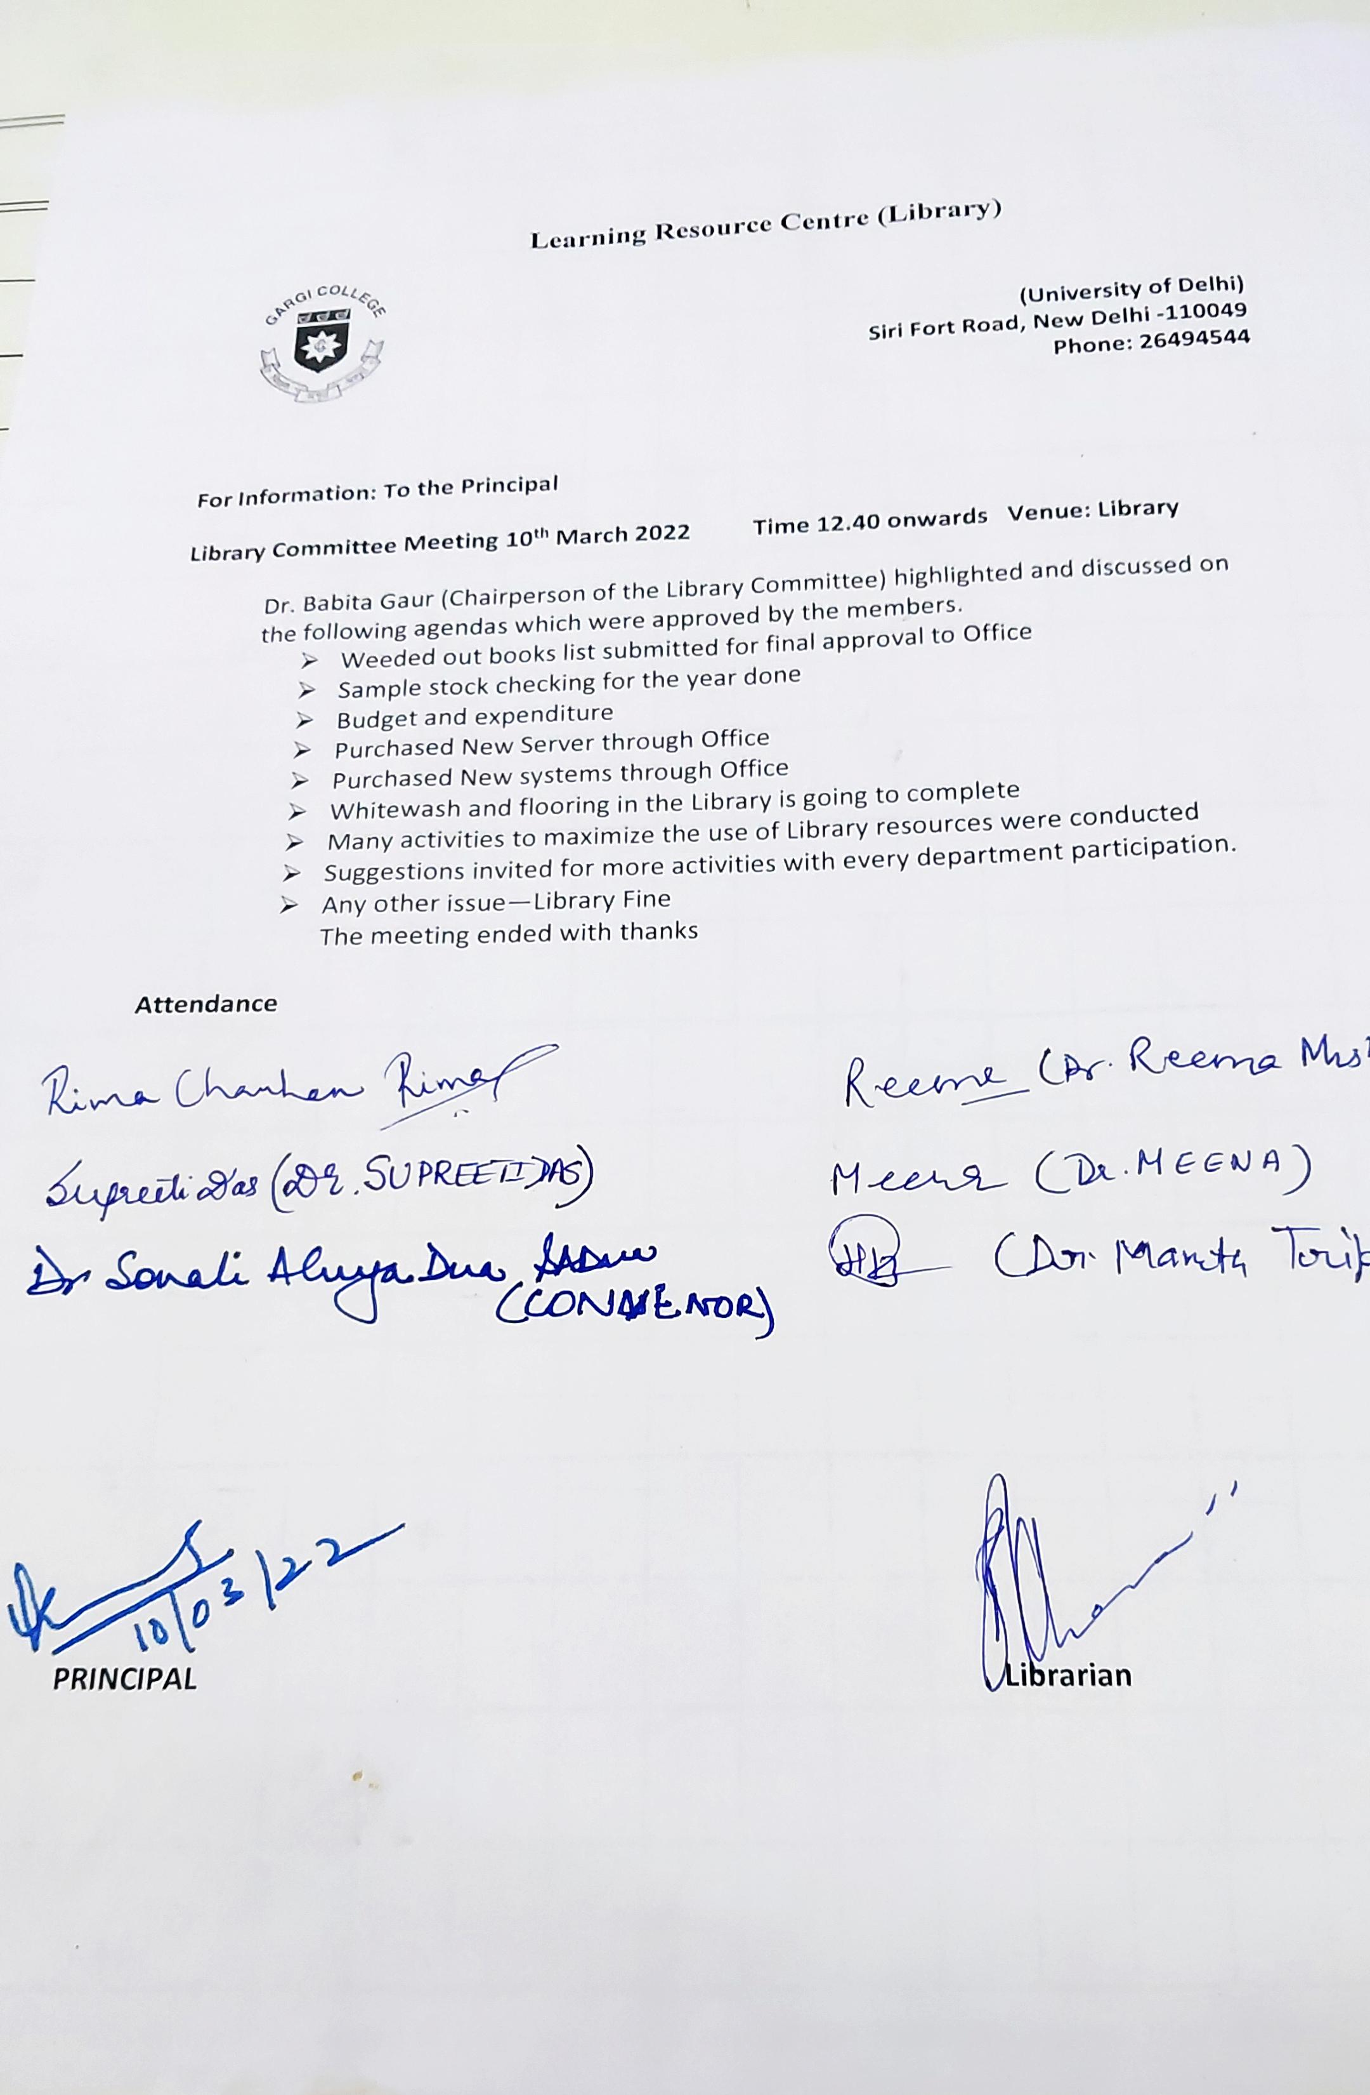
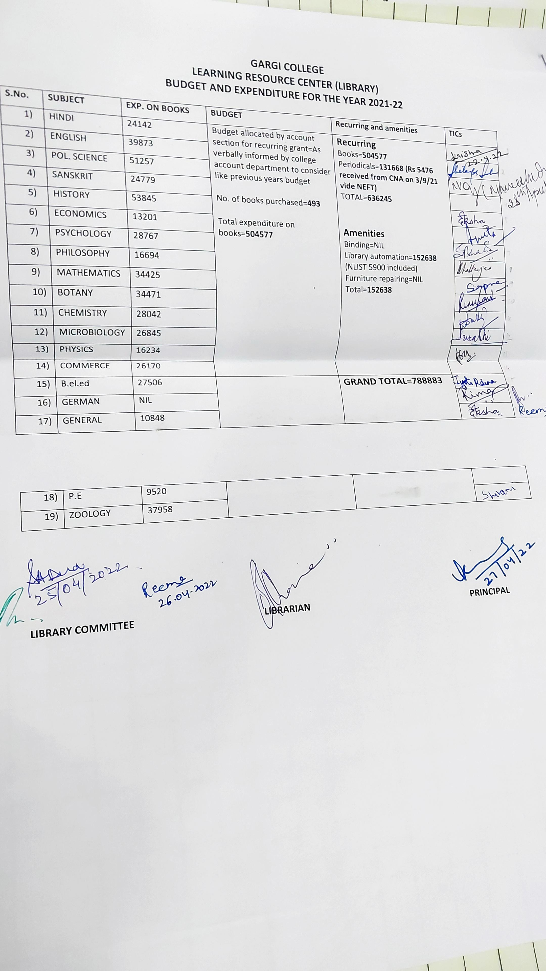
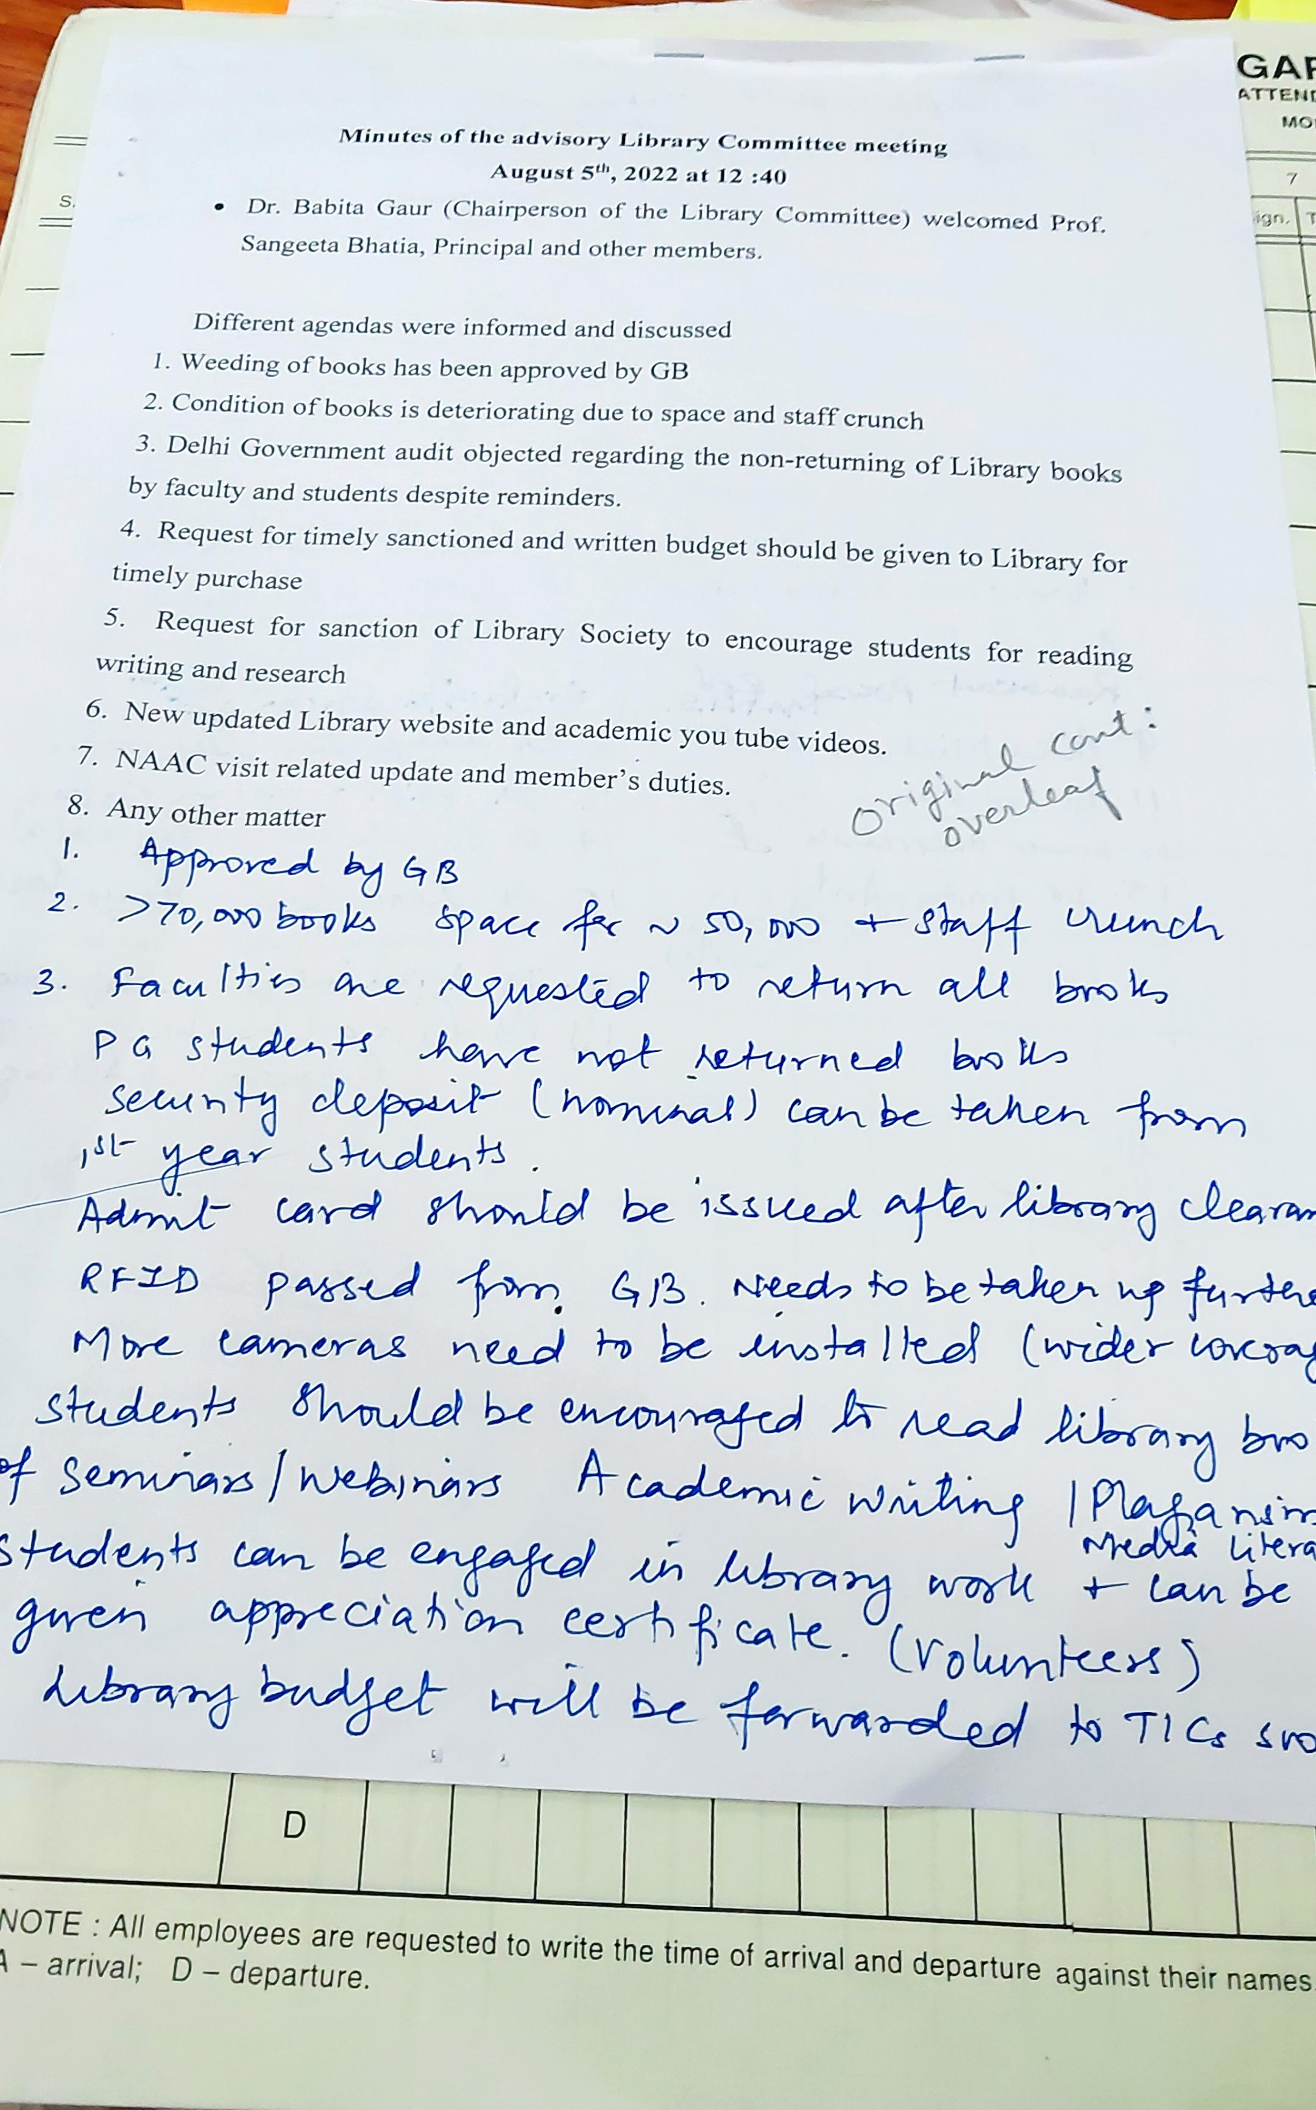
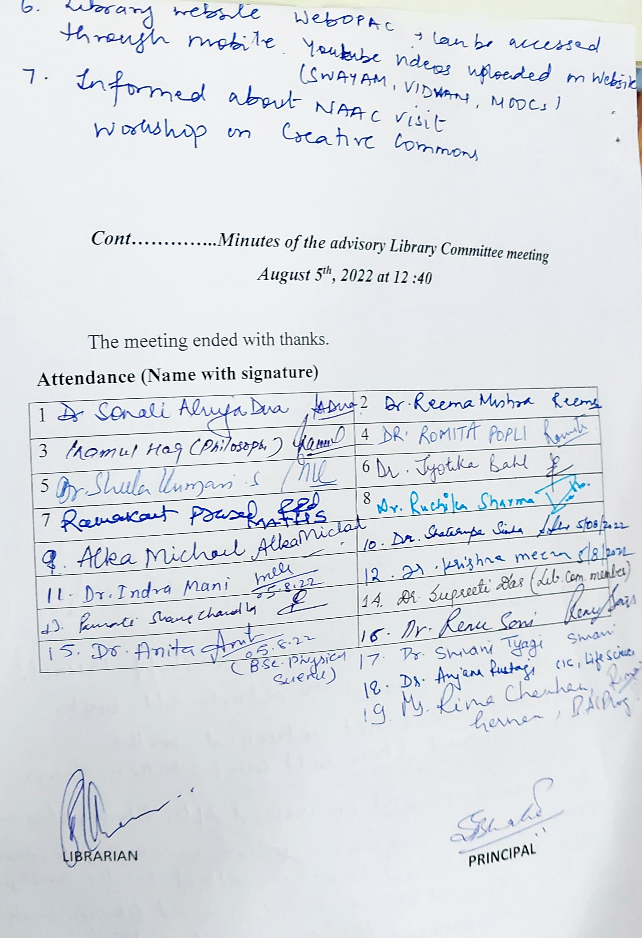

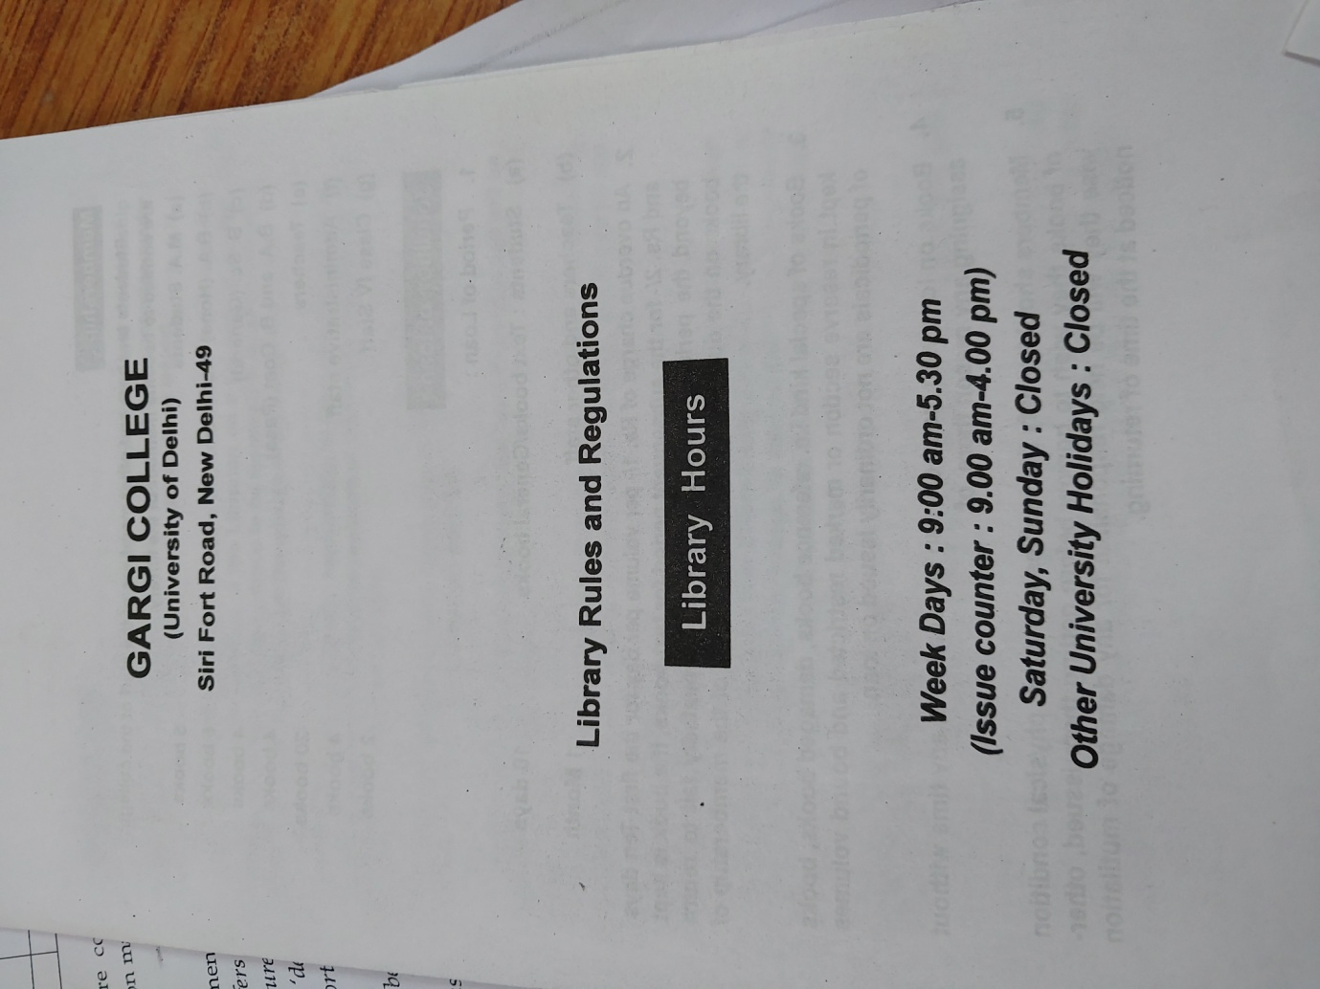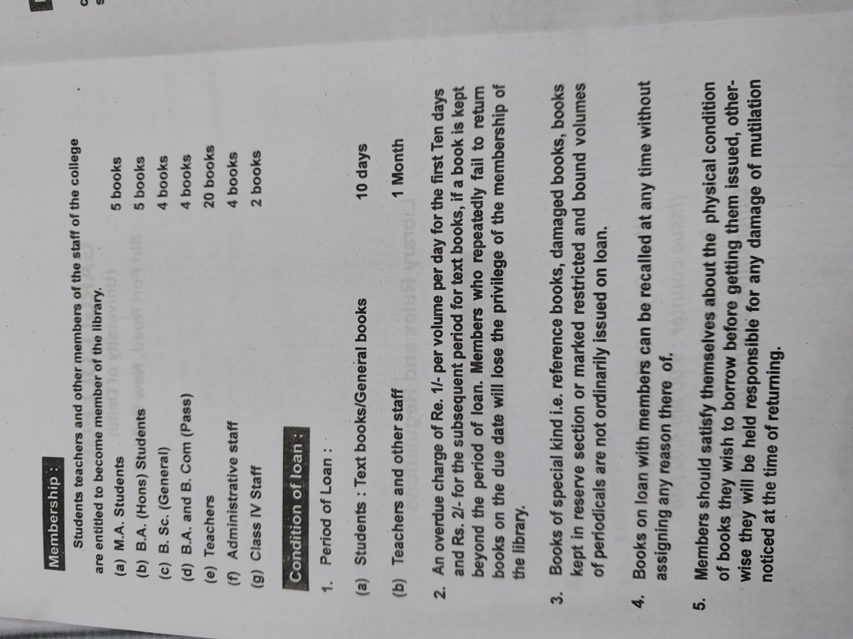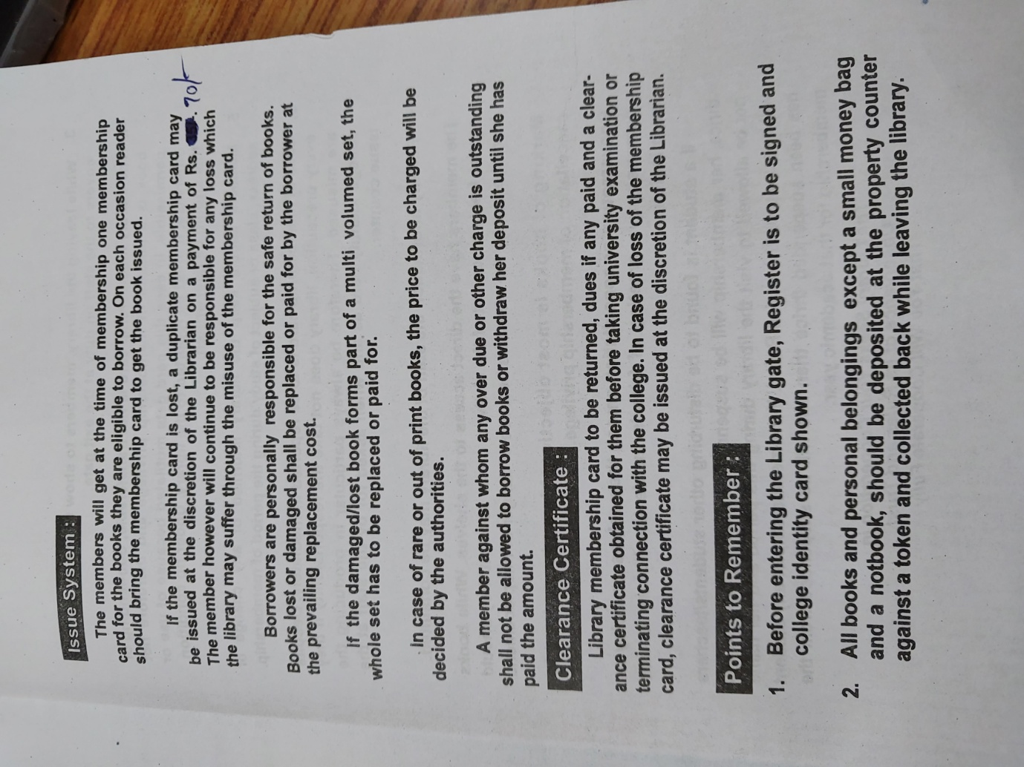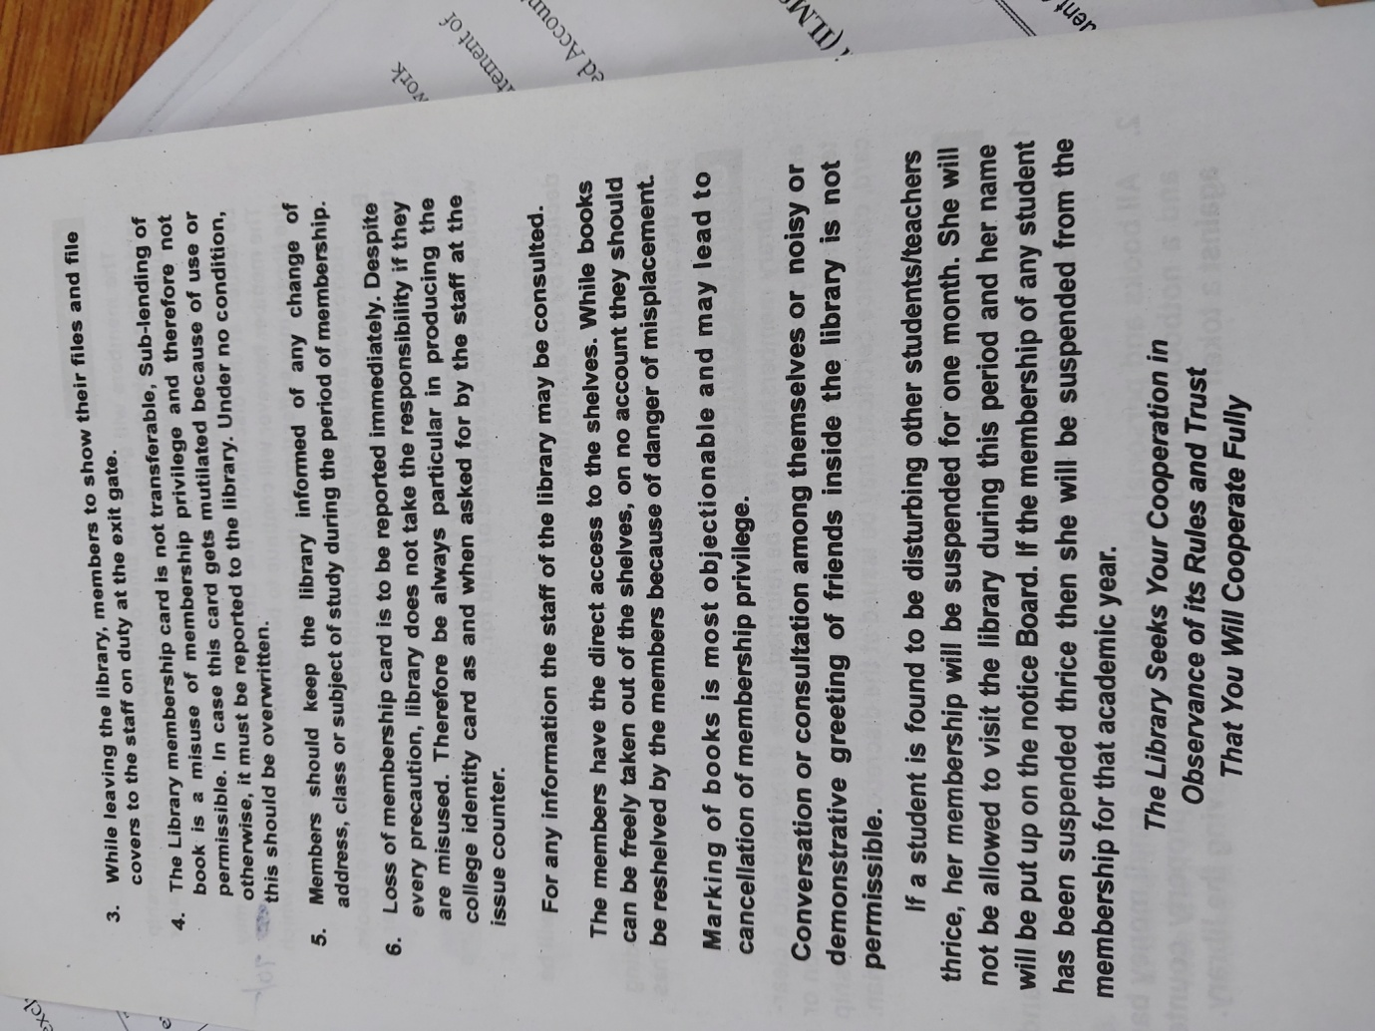

Scan 21 Dec 22 · 09·50·24.pdf

Scan 21 Dec 22 · 09·36·14.pdf

